

**Canvas**

**Build a custom numeric or categorical prediction model**

Numeric and categorical prediction models support both **Quick builds** and **Standard builds**.

To build a numeric or categorical prediction model, use the following procedure:

1. Open the SageMaker Canvas application.
2. In the left navigation pane, choose **My models**.
3. Choose **New model**.
4. In the **Create new model** dialog box, do the following:
   1. Enter a name in the **Model name** field.
   2. Select the **Predictive analysis** problem type.
   3. Choose **Create**.
5. For **Select dataset**, select your dataset from the list of datasets. If you haven’t already imported your data, choose **Import** to be directed through the import data workflow.
6. When you’re ready to begin building your model, choose **Select dataset**.
7. On the **Build** tab, for the **Target column** dropdown list, select the target for your model that you would like to predict.
8. For **Model type**, Canvas automatically chooses the problem type for you. If you want to change the type, choose **Change model type** and select your desired model type.
9. Select or deselect columns in your data to include or drop them from your build.

**Note**

If you make batch predictions with your model after building, Canvas adds dropped columns to your prediction results. However, Canvas does not add the dropped columns to your batch predictions for time series models.

1. (Optional) Use the visualization and analytics tools that Canvas provides to visualize your data and determine which features you might want to include in your model. For more information, see [Explore and analyze your data](https://docs.aws.amazon.com/sagemaker/latest/dg/canvas-explore-data.html).
2. (Optional) Use data transformations to clean, transform, and prepare your data for model building. For more information, see [Prepare your data with advanced transformations](https://docs.aws.amazon.com/sagemaker/latest/dg/canvas-prepare-data.html). You can view and remove your transforms by choosing **Model recipe** to open the **Model recipe** side panel.
3. (Optional) For additional features such as previewing the accuracy of your model, validating your dataset, and changing the size of the random sample that Canvas takes from your dataset, see [Preview your model](https://docs.aws.amazon.com/sagemaker/latest/dg/canvas-preview-model.html).
4. After reviewing your data and making any changes to your dataset, choose **Quick build** or **Standard build** to begin a build for your model. The following screenshot shows the **Build** page and the **Quick build** and **Standard build** options.

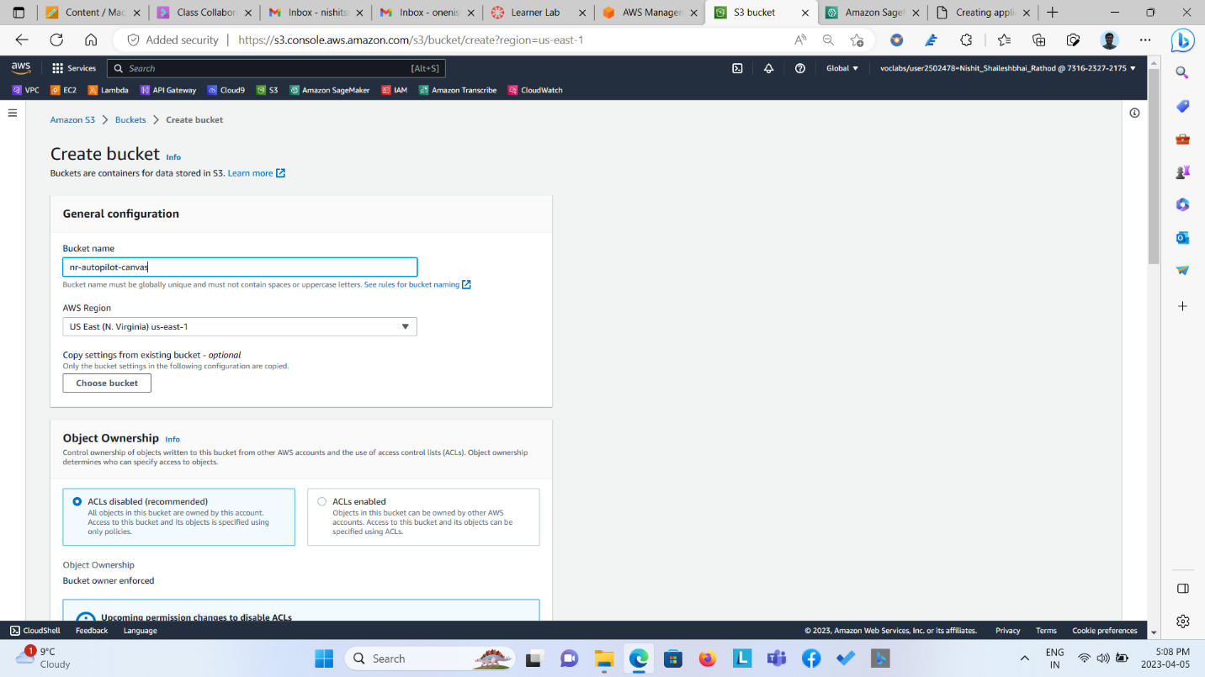

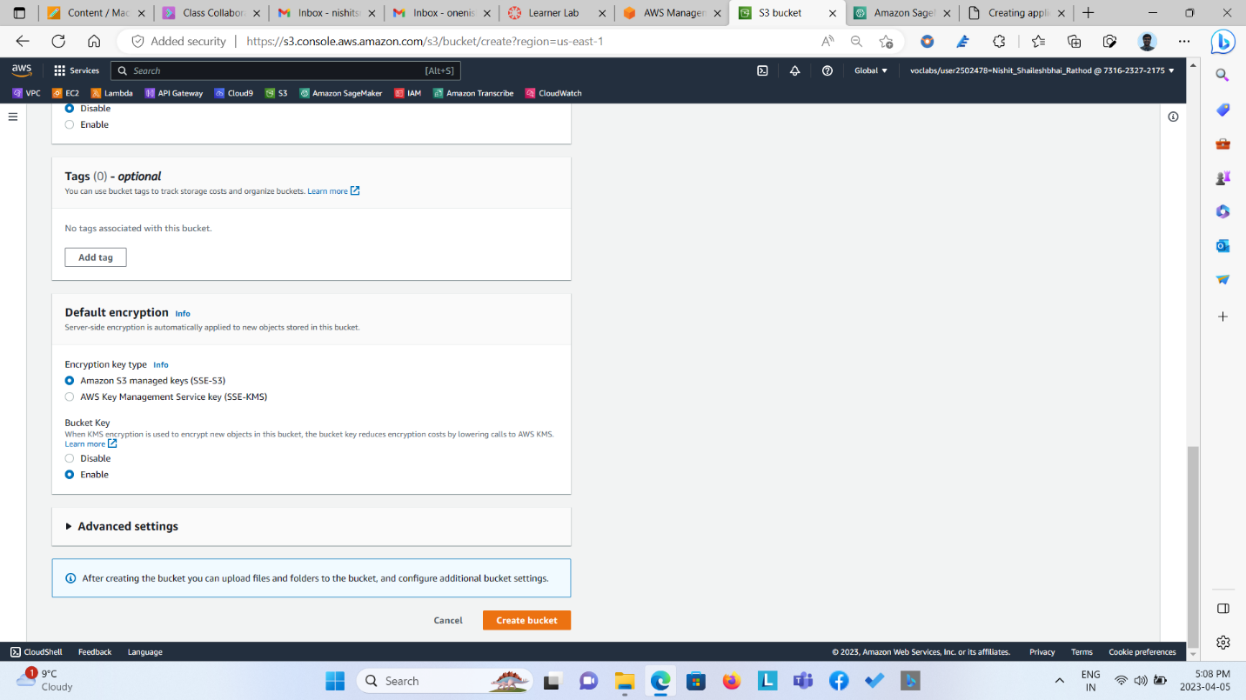

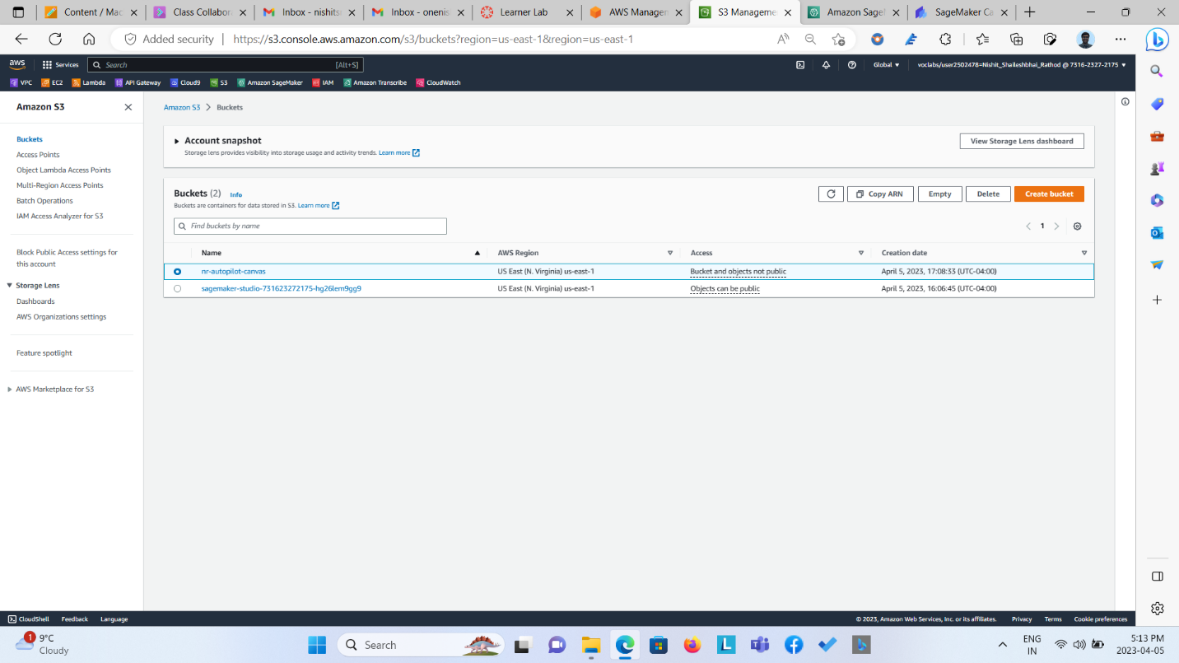

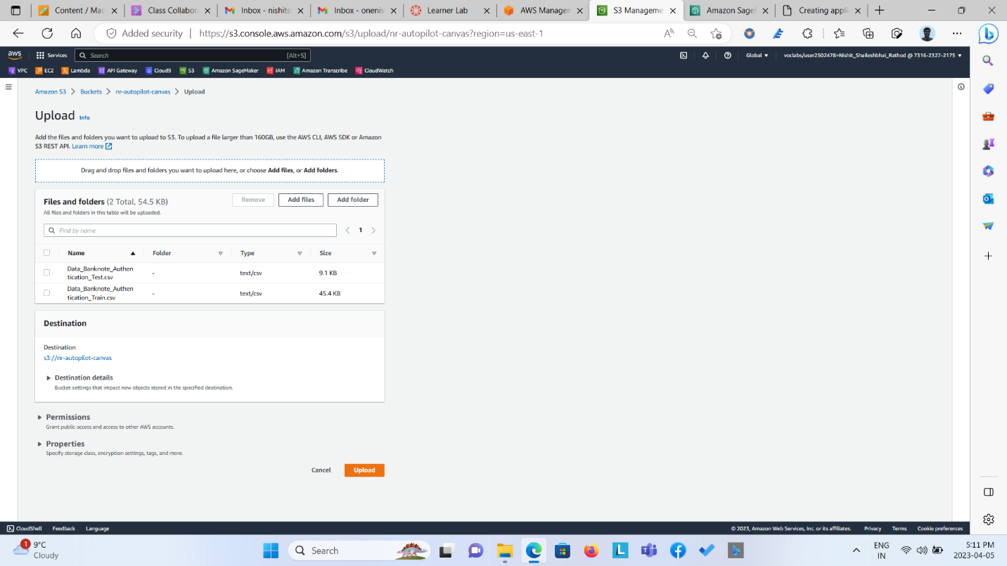

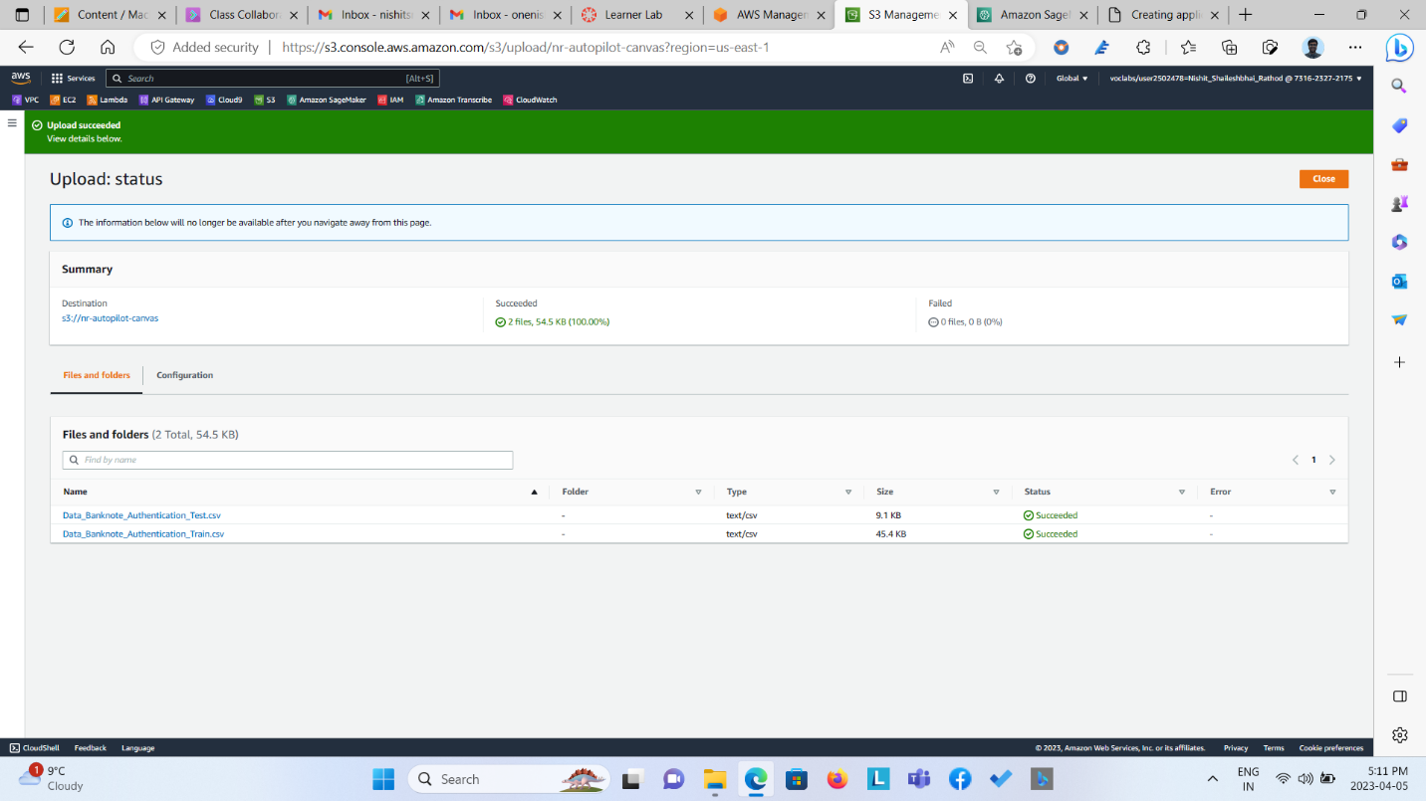

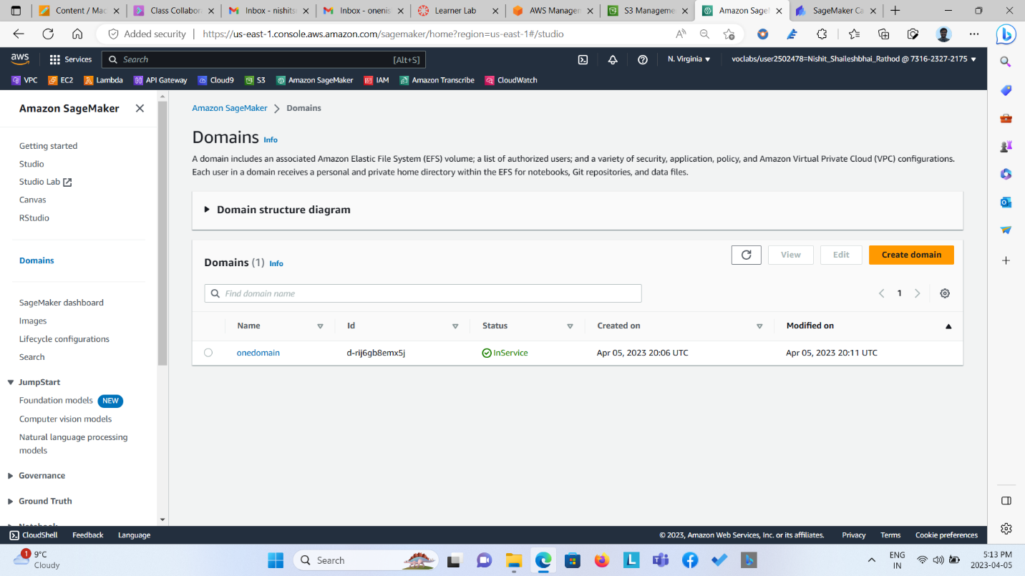

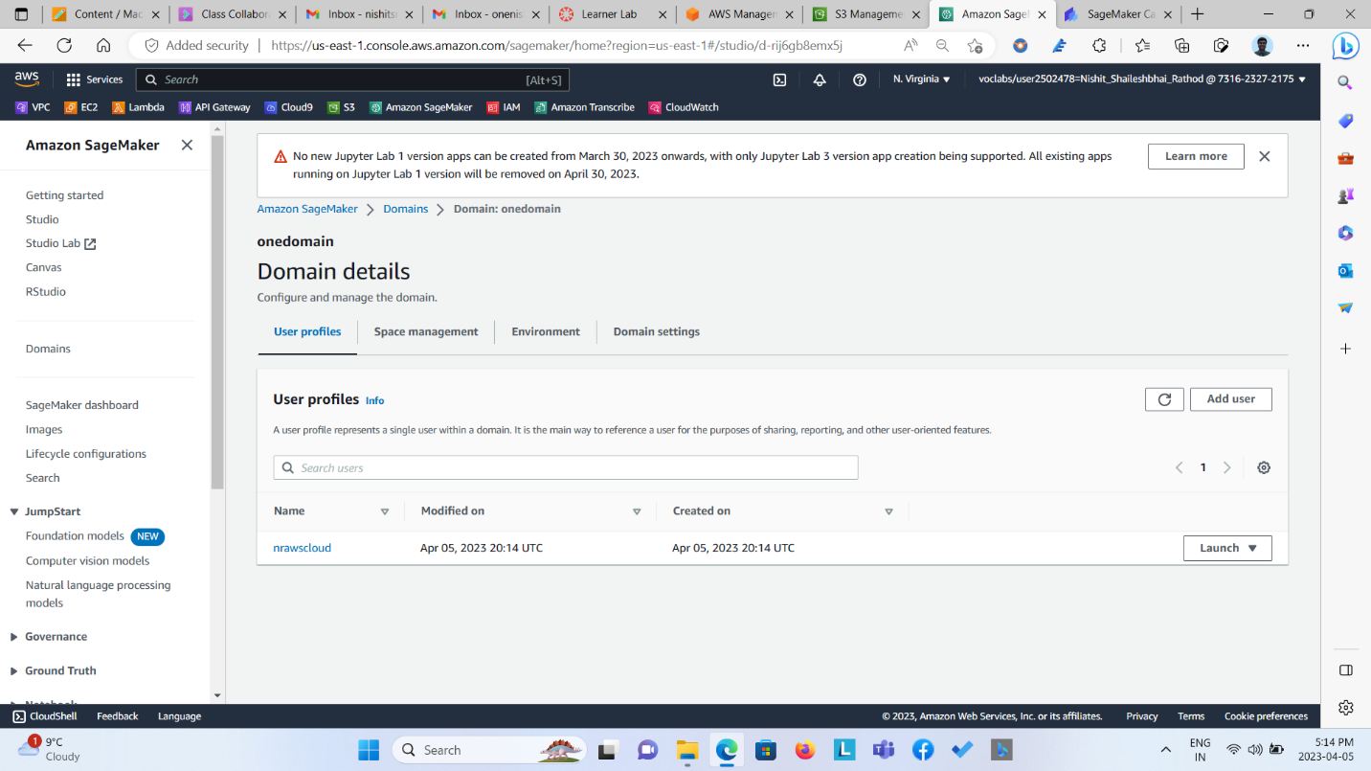

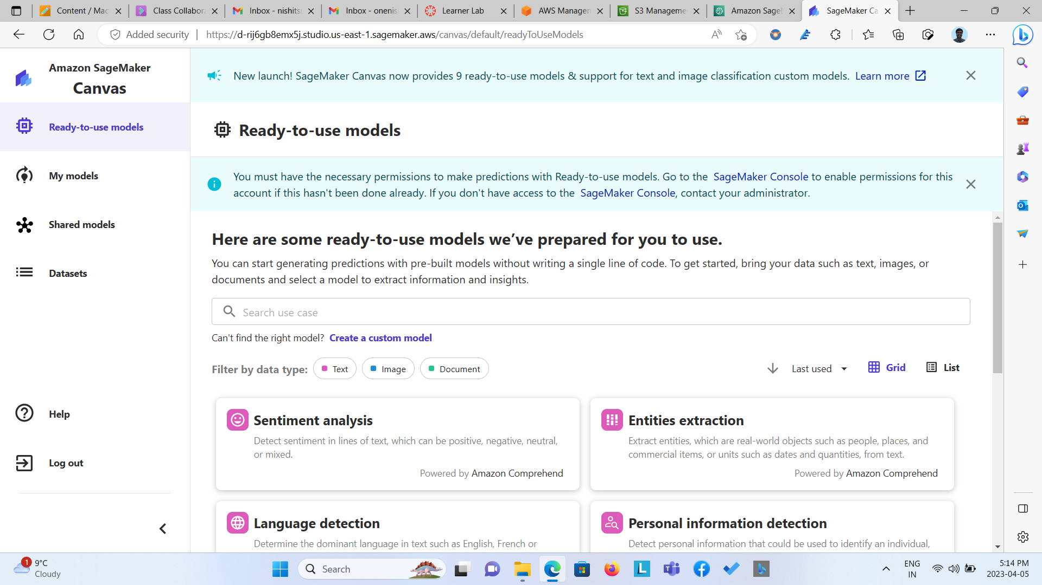  
  
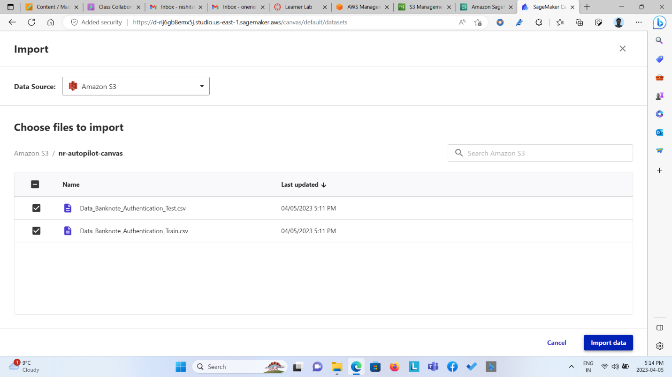  
  
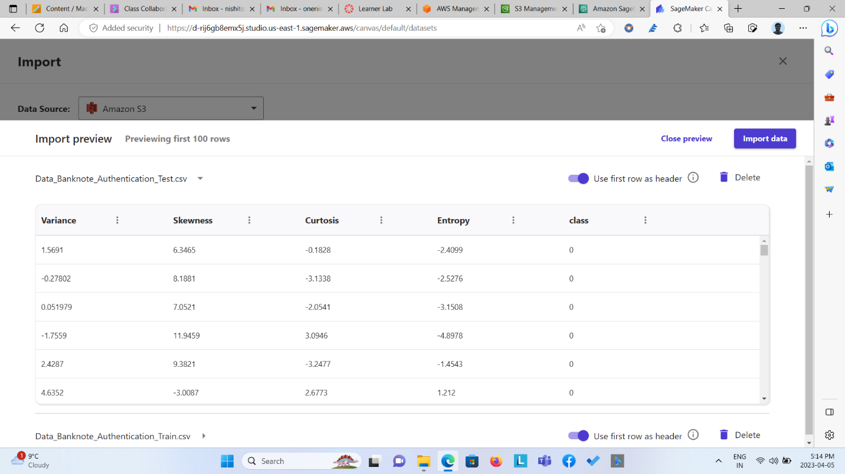  
  
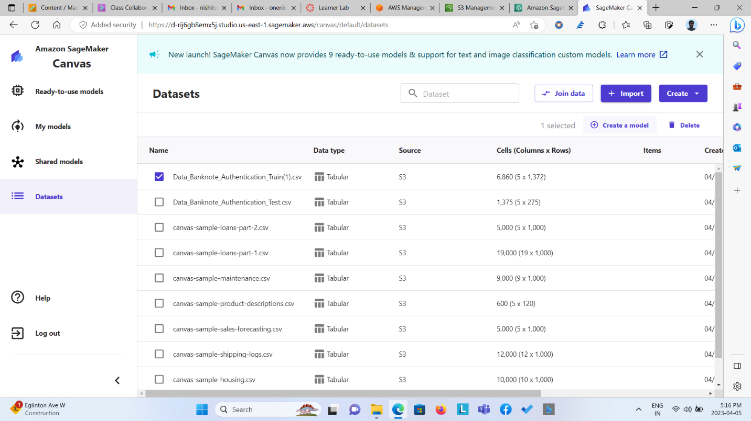  
  
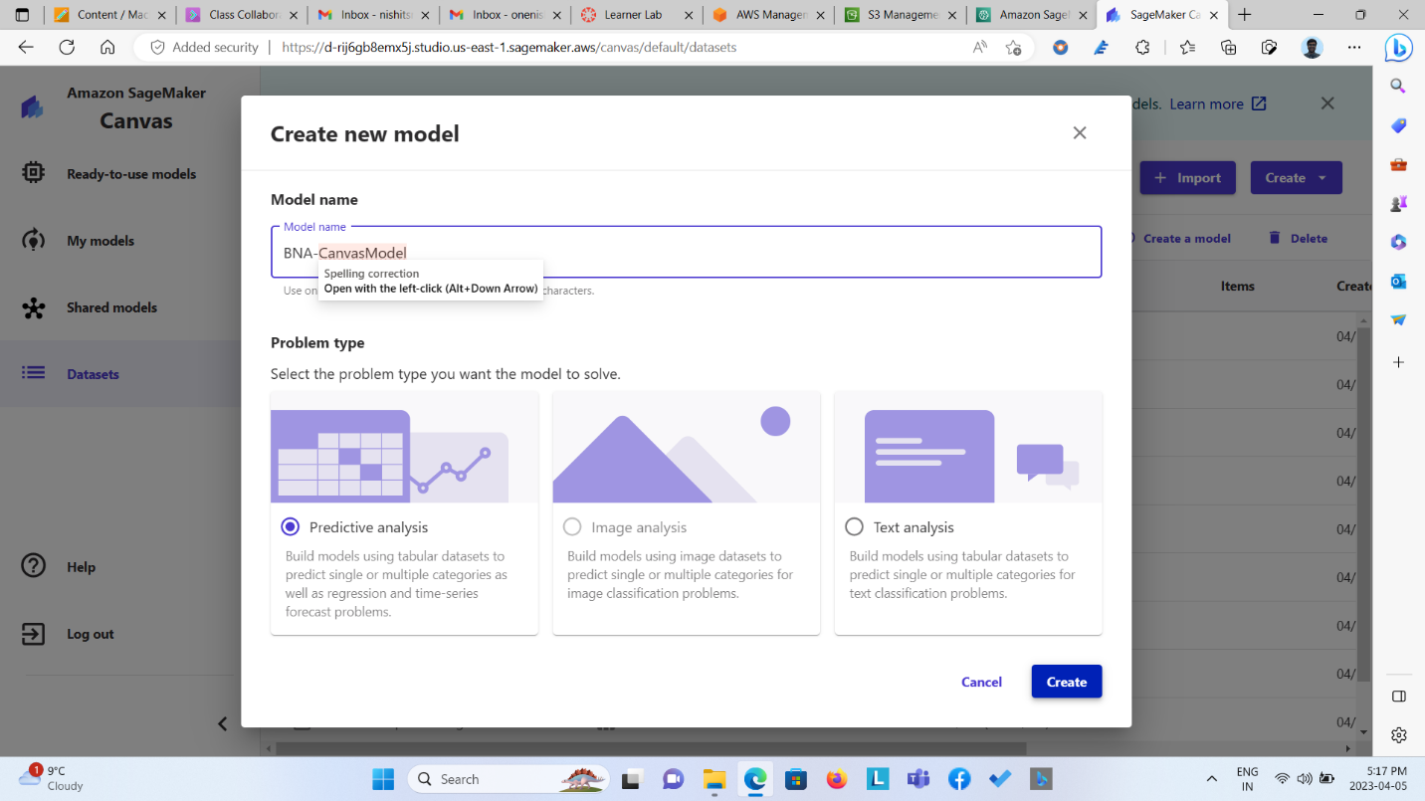  
  
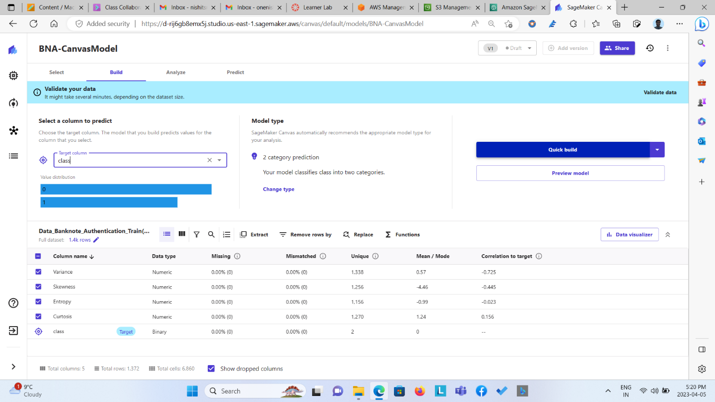  
  
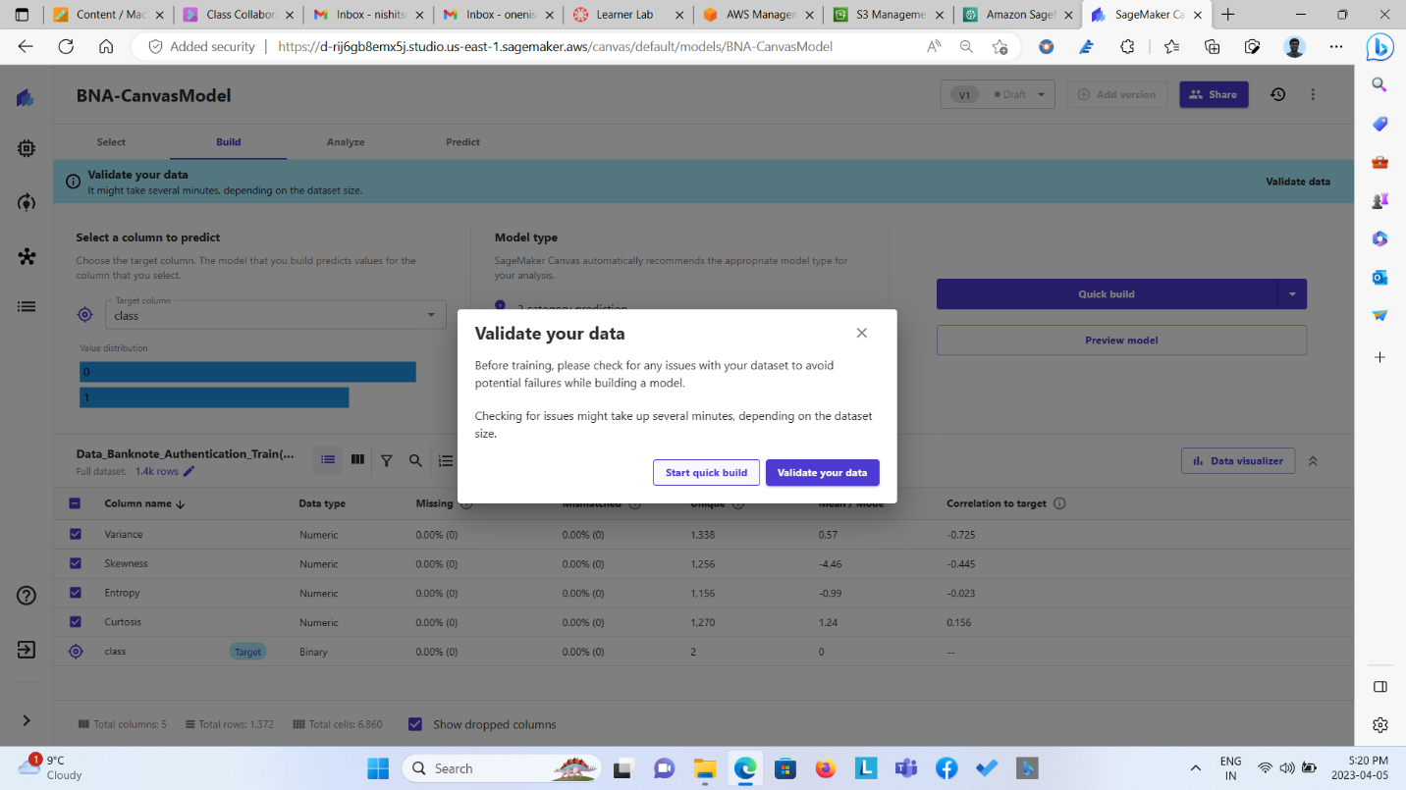  
  
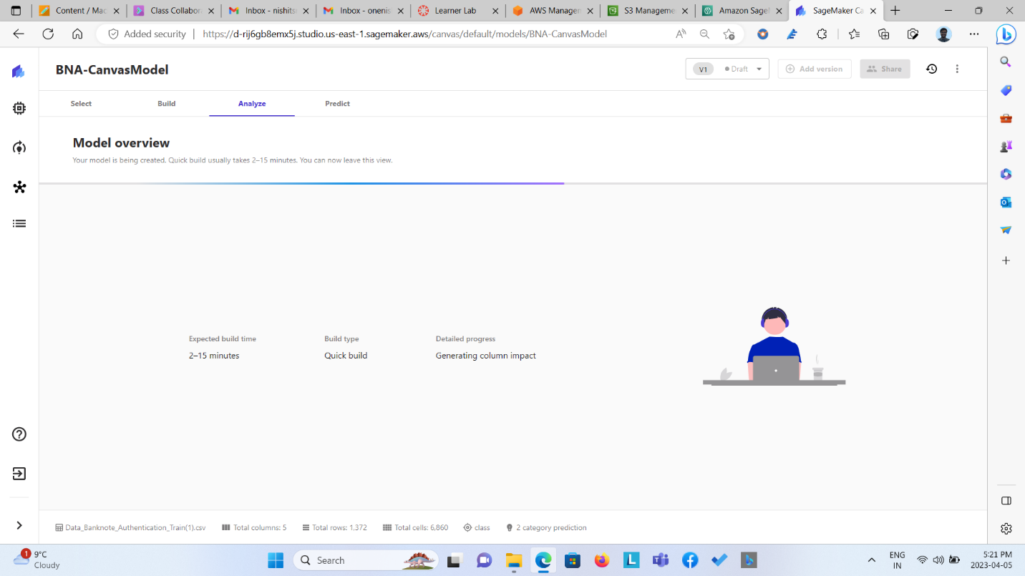  
  
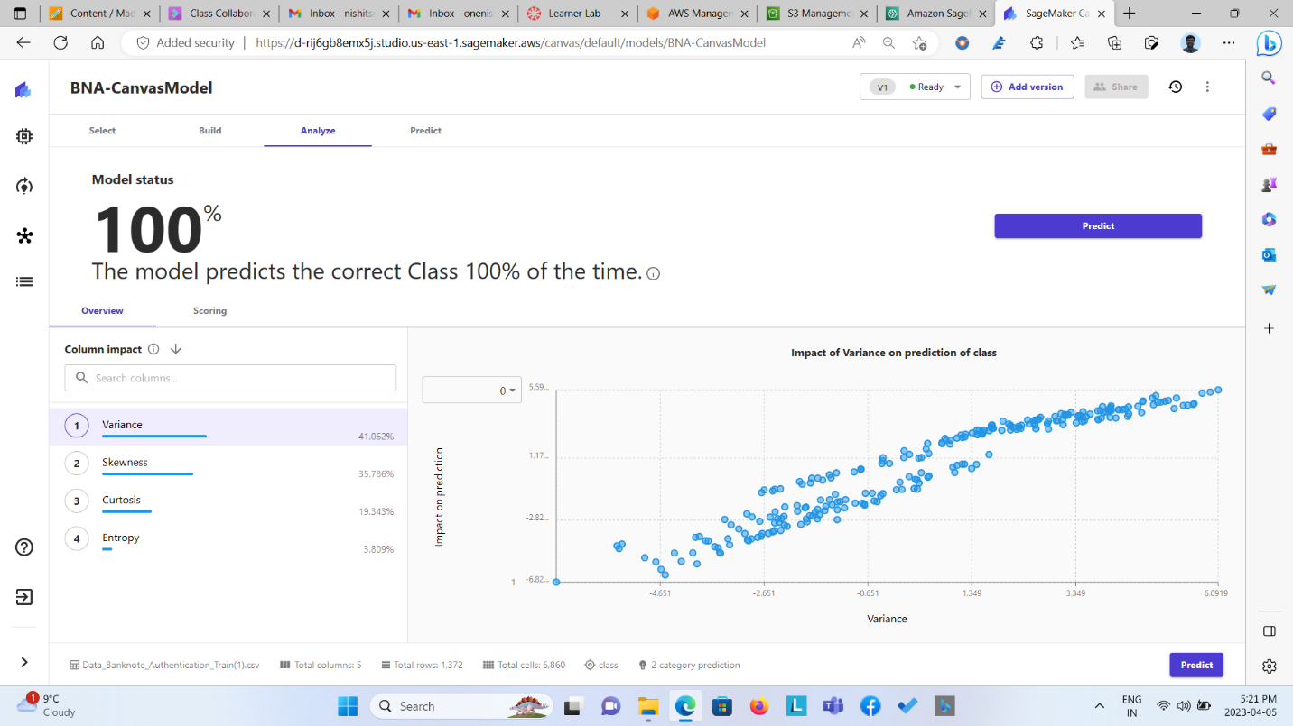

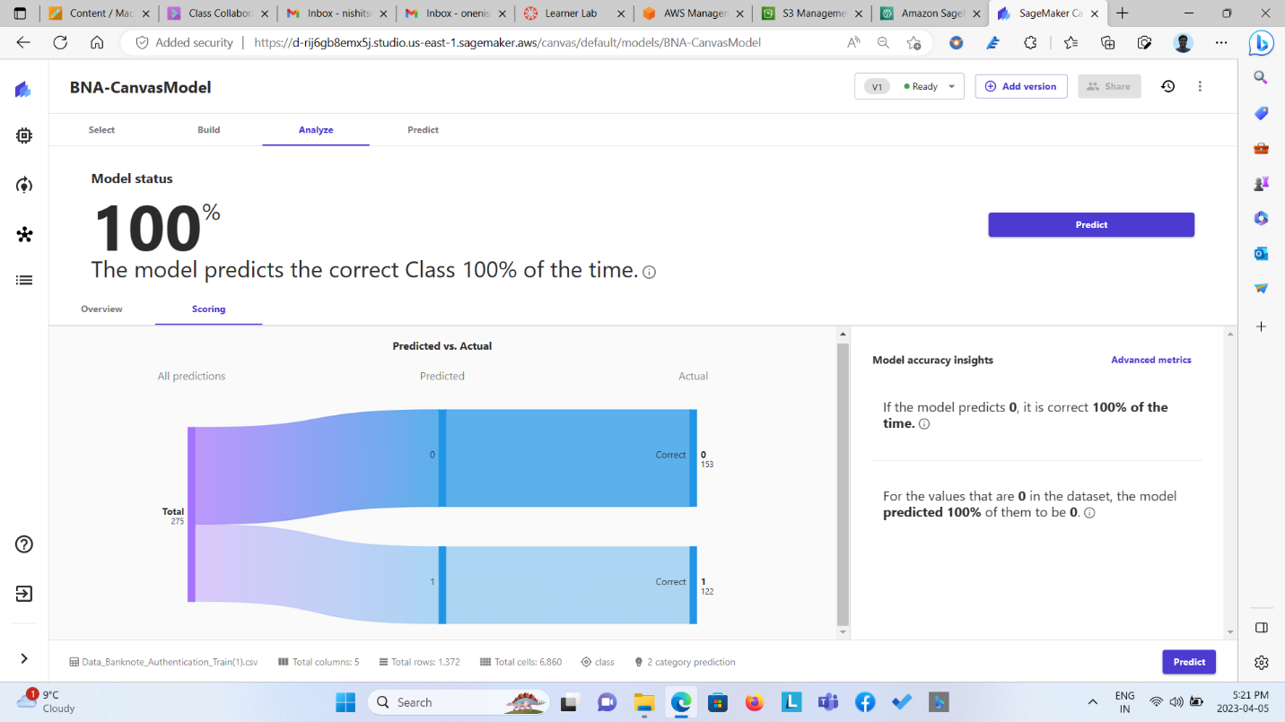  
  
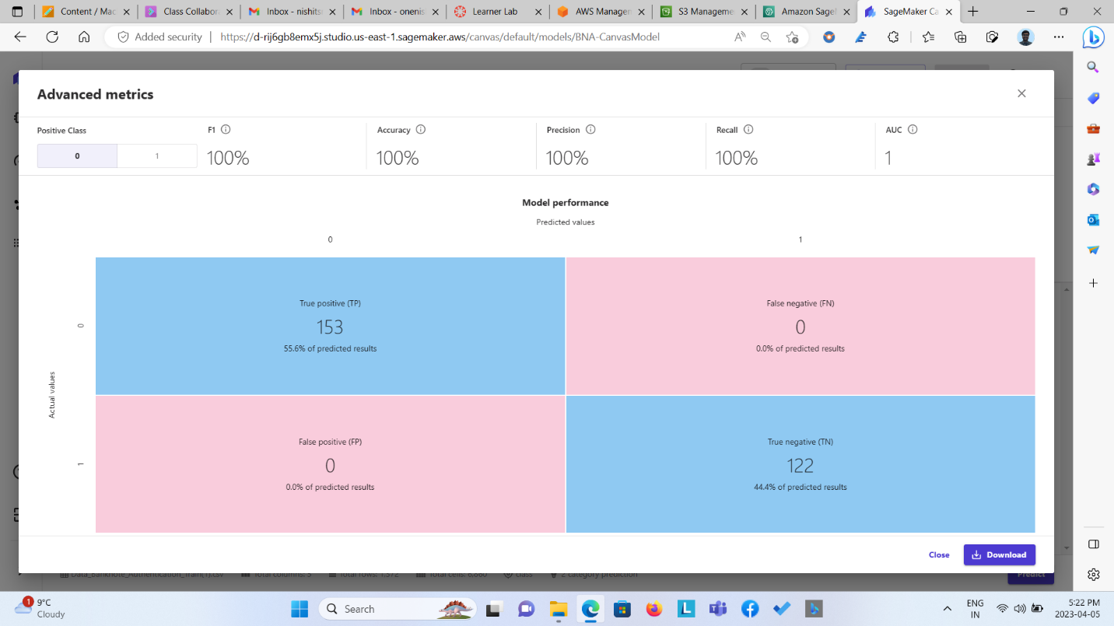  
  
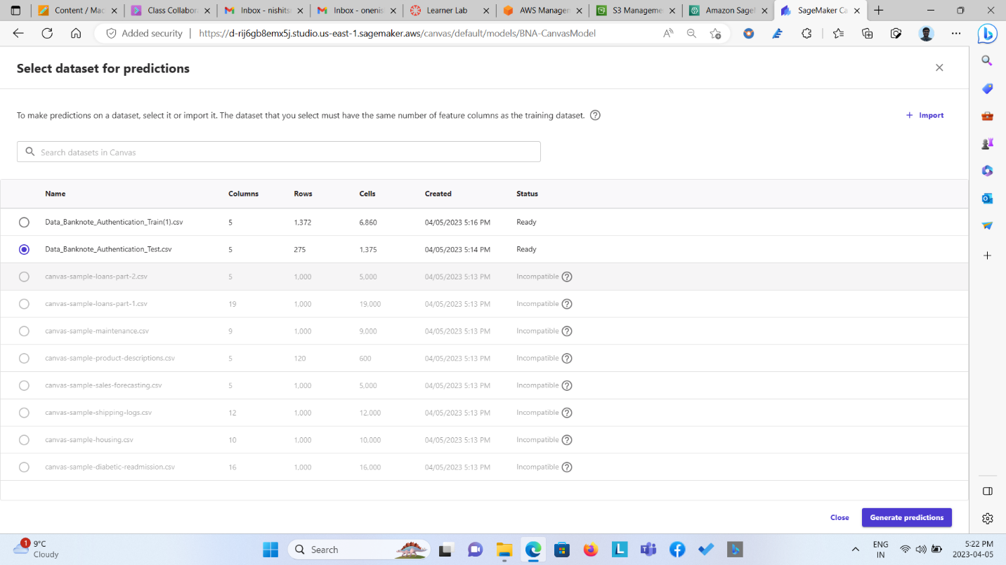  
  
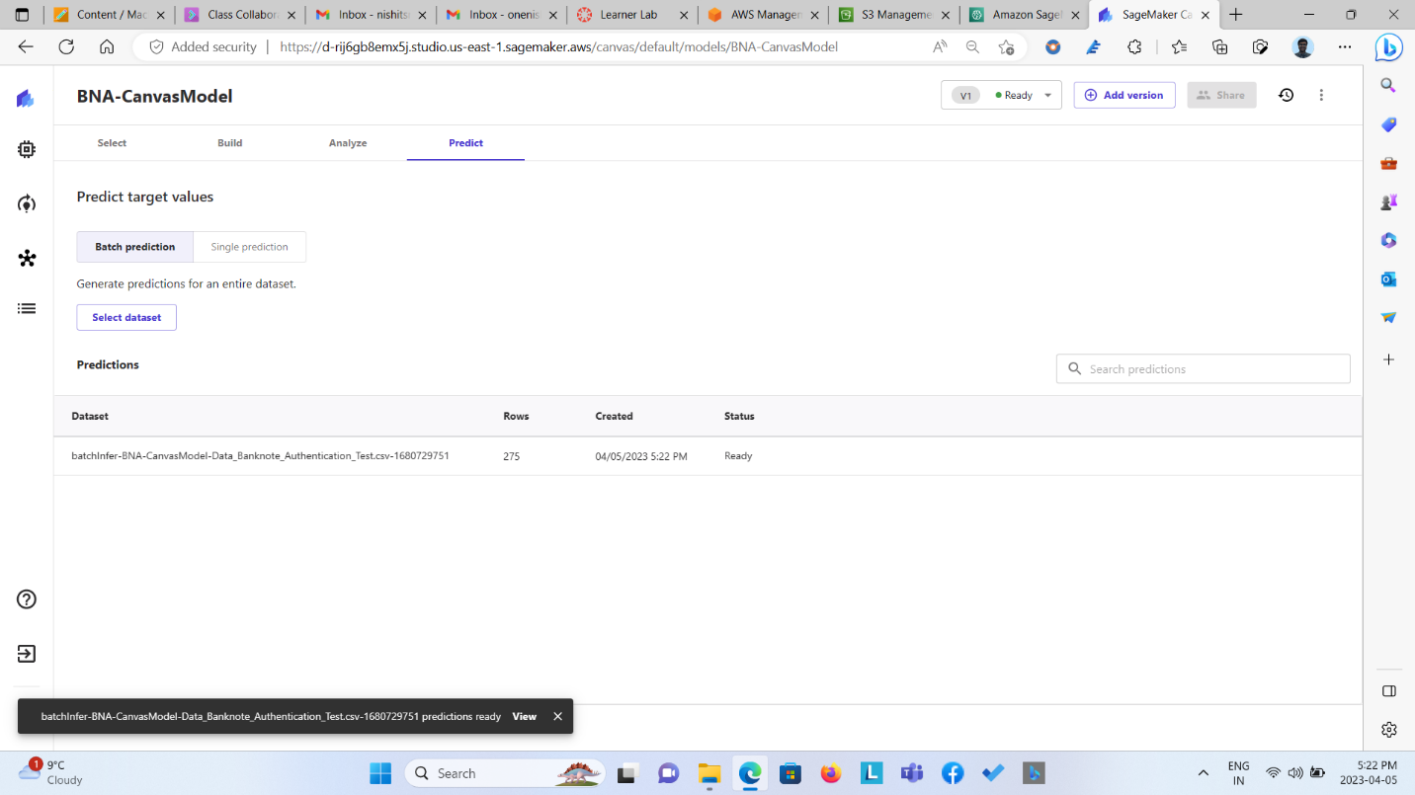  
  
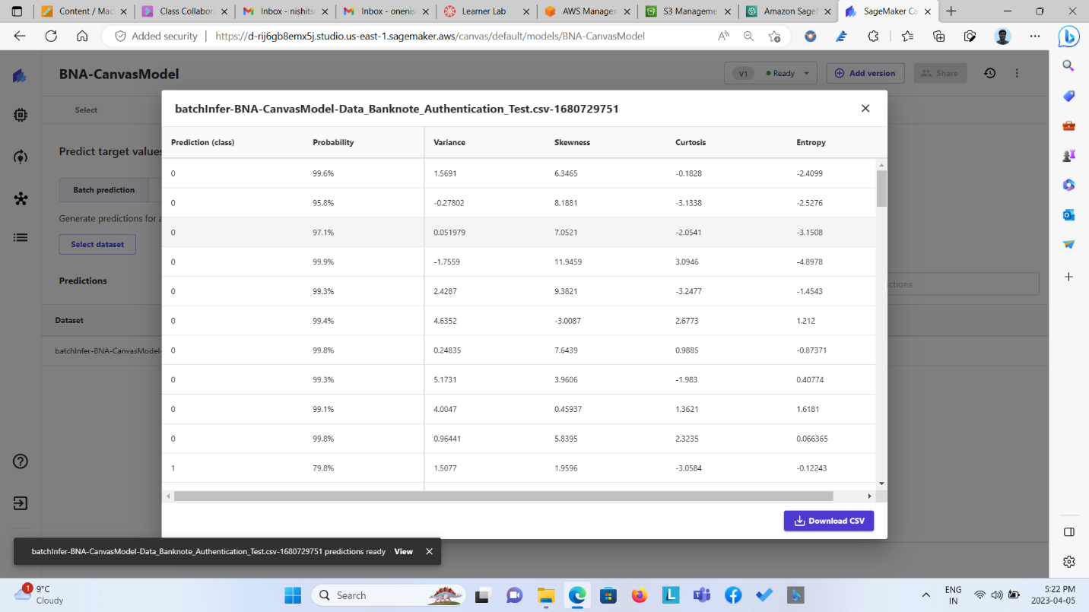

**Autopilot**

This guide shows how to create an Amazon SageMaker Autopilot experiment (that is, how to start an Autopilot job in SageMaker), so that you can explore, pre-process, and train various model candidates on a given dataset. This can help you get started with machine learning quickly.

You can use a user interface (Amazon SageMaker Studio UI) to help you populate the input, output, target, and parameters to run and evaluate an Autopilot experiment or use SageMaker API Reference. The UI has descriptions, toggle switches, dropdown menus, radio buttons, and more to help you navigate creating your model candidates. You can also view statistics while the experiment is running. After it runs, you can compare trials and delve into the details of the pre-processing steps, algorithms, and hyperparameter ranges of each model. You also have the option to download their [explainability](https://docs.aws.amazon.com/sagemaker/latest/dg/autopilot-explainability.html) and [performance](https://docs.aws.amazon.com/sagemaker/latest/dg/autopilot-model-insights.html) reports. Use the provided [notebooks](https://docs.aws.amazon.com/sagemaker/latest/dg/autopilot-automate-model-development-notebook-output.html) to see the results of the automated data exploration or the candidate model definitions.

The following instructions show how to create an Amazon SageMaker Autopilot job as a pilot experiment using Studio UI or SageMaker API reference. You name your experiment, provide locations for the input and output data, and specify which target data to predict. Optionally, you can also specify the type of machine learning problem that you want to solve, choose your modeling strategy (*stacked ensembles* or *hyperparameters optimization*), select the list of algorithms used by the Autopilot job to train the data, and more.

**Create an Autopilot experiment using Studio**

To create an Amazon SageMaker Autopilot experiment using Studio

1. Sign in at <https://console.aws.amazon.com/sagemaker/>, select Studio from the left navigation pane, then choose Open Studio.
2. In Studio, choose the home icon (  ) from the left navigation pane to view the Studio top-level navigation menu.
3. On the Home tab, choose the AutoML card. This opens a new AutoML tab.
4. Choose Create an AutoML experiment. This opens a new Create experiment tab.
5. In the Experiment and data details section, enter the following information:
   1. Experiment name – Must be unique to your account in the current AWS Region and contain a maximum of 63 alphanumeric characters. Can include hyphens (-) but not spaces.
   2. Input data – Provide the Amazon Simple Storage Service (Amazon S3) bucket location of your input data. This S3 bucket must be in your current AWS Region. The URL must be in an s3:// format where Amazon SageMaker has write permissions. The file must be in CSV or Parquet format and contain at least 500 rows. Select Browse to scroll through available paths and Preview to see a sample of your input data.
   3. Is your S3 input a manifest file? – A manifest file includes metadata with your input data. The metadata specifies the location of your data in Amazon S3. It also specifies how the data is formatted and which attributes from the dataset to use when training your model. You can use a manifest file as an alternative to preprocessing when your labeled data is being streamed in Pipe mode.
   4. Auto split data? – Autopilot can split your data into an 80-20% split for training and validation data. If you prefer a custom split, you can choose the Specify split ratio. To use a custom dataset for validation, choose Provide a validation set.
   5. Output data location (S3 bucket) – The name of the S3 bucket location where you want to store the output data. The URL for this bucket must be in an Amazon S3 format where Amazon SageMaker has write permissions. The S3 bucket must be in the current AWS Region. Autopilot can also create this for you in the same location as your input data.
6. Choose Next: Target and features. The Target and features tab opens.
7. In the Target and features section, select a column to set as a target for model predictions. You can also select features for training and change their data type. The following data types are available: Text, Numerical, Categorical, Datetime, Sequence, and Auto. All features are selected by default.
8. Choose Next: Training method. The Training method tab opens.
9. In the Training method section, select your training option: Ensembling, Hyperparameter optimization (HPO), or Auto to let Autopilot choose the training method automatically based on the dataset size. Each training mode runs a pre-defined set of algorithms on your dataset to train model candidates. By default, Autopilot pre-select all the available algorithms for the given training mode. You can run an Amazon SageMaker Autopilot training experiment with all the algorithms or choose your own subset.

For more information on the training modes and the available algorithms, see the Autopilot training modes section in the [Training modes and algorithms](https://docs.aws.amazon.com/sagemaker/latest/dg/autopilot-model-support-validation.html) page.

1. Choose Next: Deployment and advanced settings to open the Deployment and advanced settings tab. Settings include auto display endpoint name, machine learning problem type, and additional choices for running your experiment.
   1. Deployment settings – Autopilot can automatically create an endpoint and deploy your model for you.

To auto deploy to an automatically generated endpoint, or to provide an endpoint name for custom deployment, set the toggle to Yes under Auto deploy? If you are importing data from Amazon SageMaker Data Wrangler, you have additional options to auto deploy the best model with or without the transforms from Data Wrangler.

Note

If your Data Wrangler flow contains multi-row operations such as groupby, join, or concatenate, you won't be able to auto deploy with these transforms. For more information see [Automatically Train Models on Your Data Flow](https://docs.aws.amazon.com/sagemaker/latest/dg/data-wrangler-autopilot.html).

* 1. Advanced settings (optional) – Autopilot provides additional controls to manually set experimental parameters such as defining your problem type, time constraints on your Autopilot job and trials, security, and encryption settings.
     1. Machine learning problem type – Autopilot can automatically select the machine learning problem type. If you prefer to choose it manually, use the Select the machine learning problem type dropdown menu.
        1. Auto – Autopilot infers the problem type from the values of the attribute that you want to predict. In some cases, SageMaker is unable to infer accurately. When that happens, you must provide the value for the job to succeed.
        2. Binary classification– Binary classification is a type of supervised learning that assigns an individual to one of two predefined and mutually exclusive classes, based on their attributes. For example, medical diagnosis based on results of diagnostic tests that determine if someone has a disease.
        3. Regression – Regression estimates the values of a dependent target variable based on one or more variables or attributes that are correlated with it. For example, house prices based on features, such as square footage and number of bathrooms.
        4. Multiclass classification – Multiclass classification is a type of supervised learning that assigns an individual to one of several classes based on their attributes. For example, the prediction of the topic most relevant to a text document, such as politics, finance, or philosophy.
  2. Choose Next: Review and create to get a summary of your Autopilot experiment before you create it.

1. Select Create experiment.The creation of the experiment starts an Autopilot job in SageMaker. Autopilot provides status on the course of the experiment, information on the data exploration process and model candidates in notebooks, a list of generated models and their reports, and the job profile used to create them.

For information on the notebooks generated by an Autopilot job, see [Amazon SageMaker Autopilot notebooks generated to manage AutoML tasks](https://docs.aws.amazon.com/sagemaker/latest/dg/autopilot-automate-model-development-notebook-output.html). For information on the details of each model candidate and their reports, see [Models generated by Amazon SageMaker Autopilot](https://docs.aws.amazon.com/sagemaker/latest/dg/autopilot-models.html).

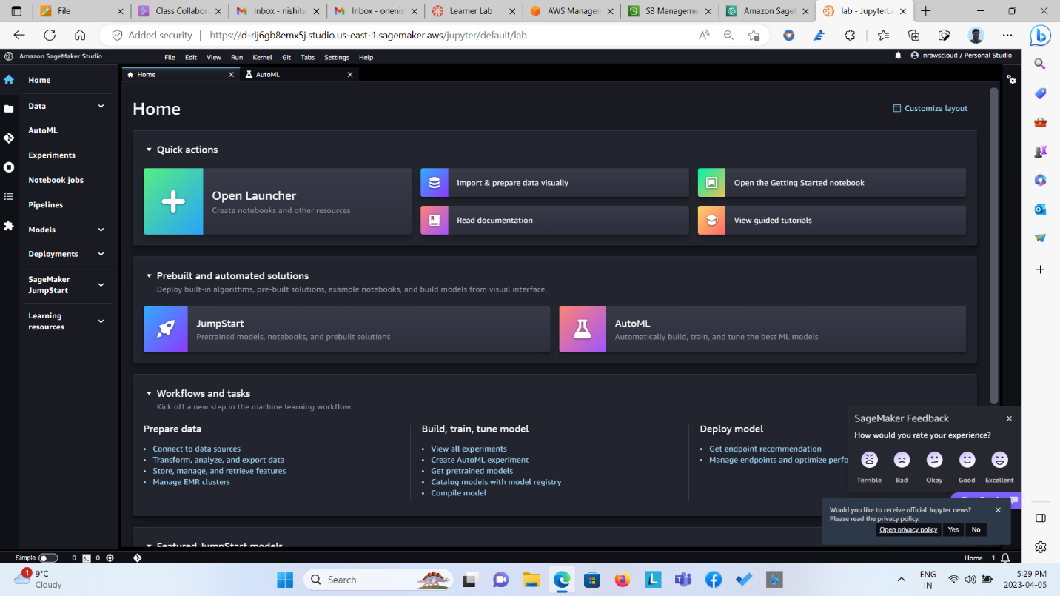

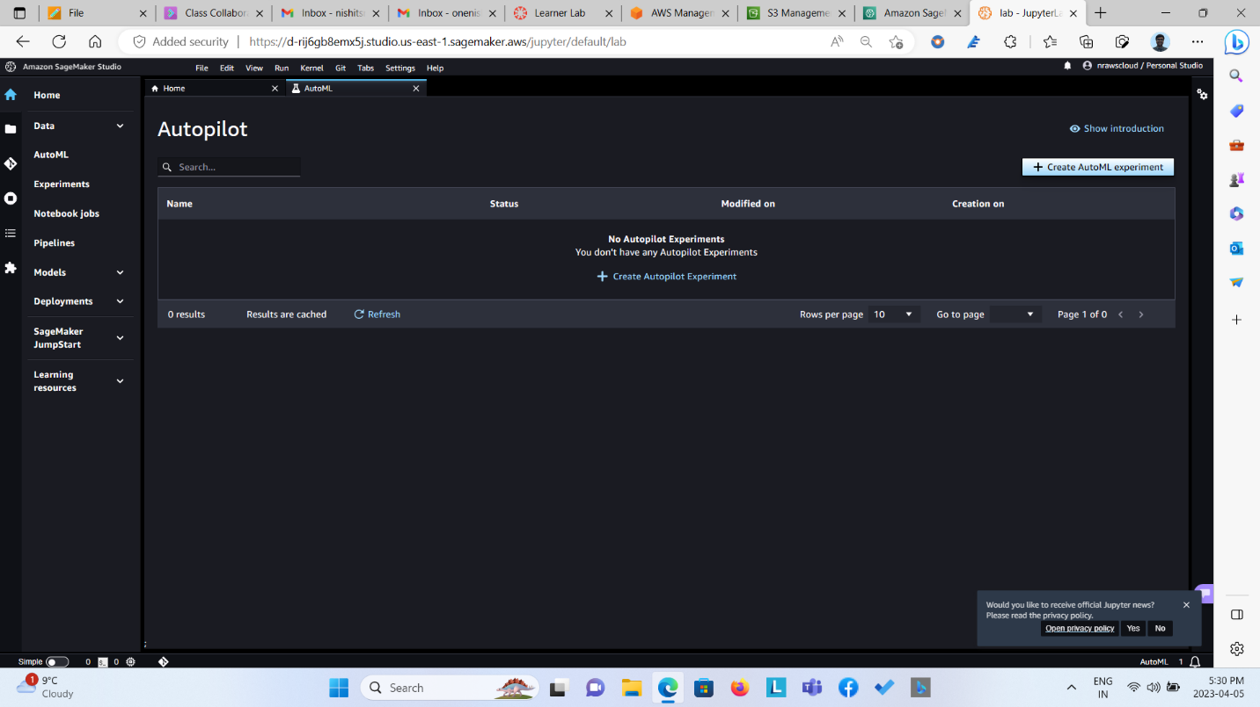

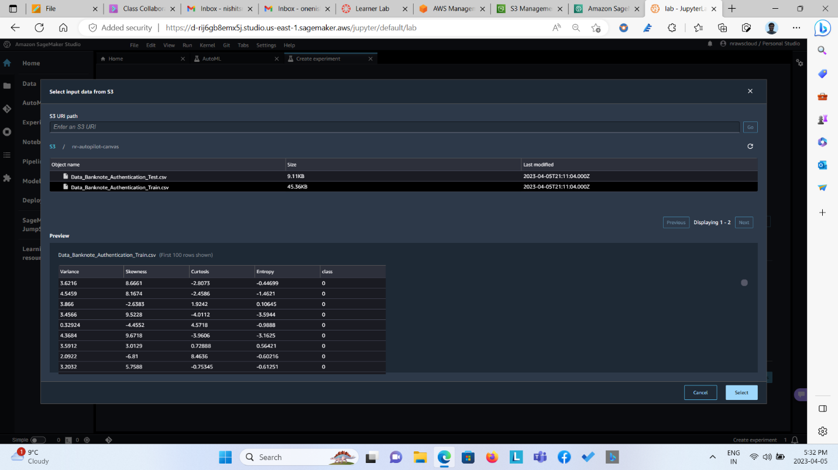  
  
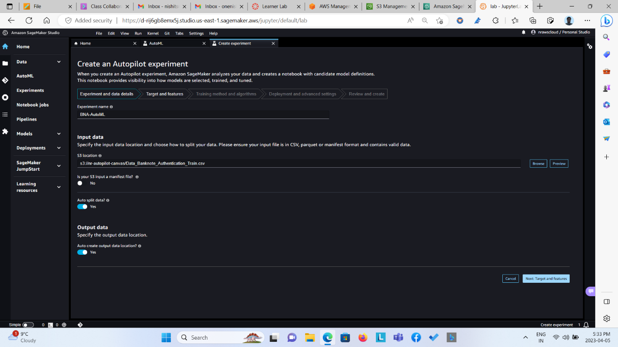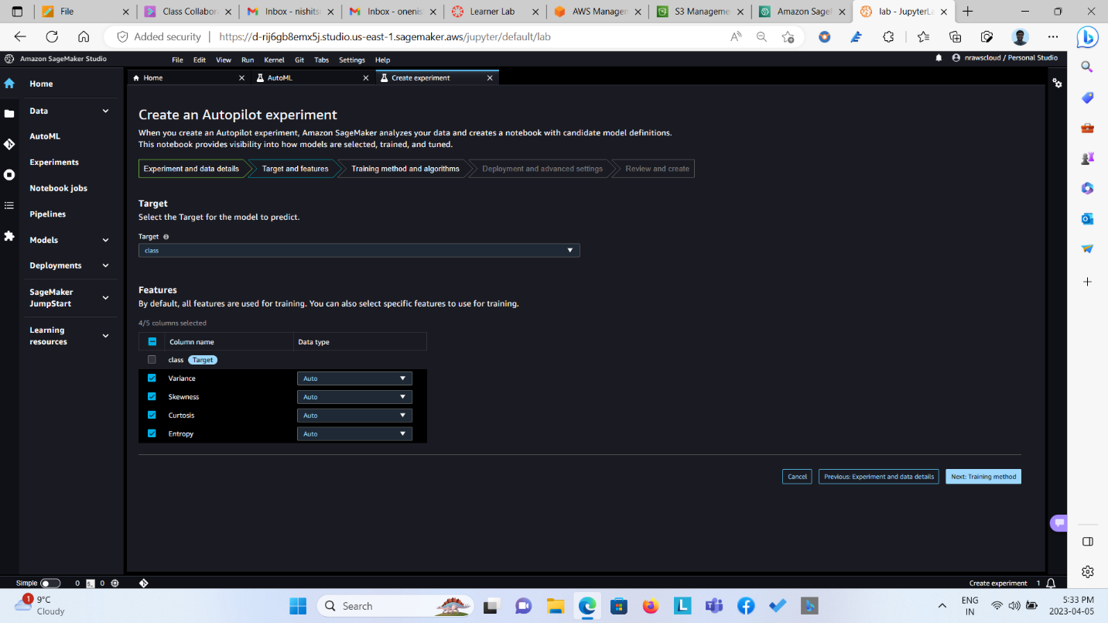  
  
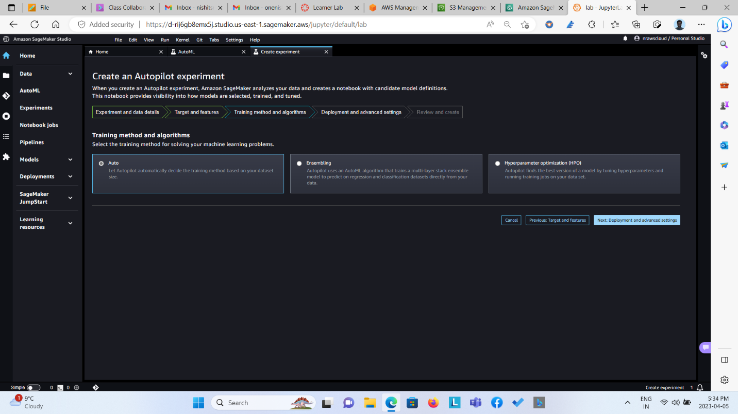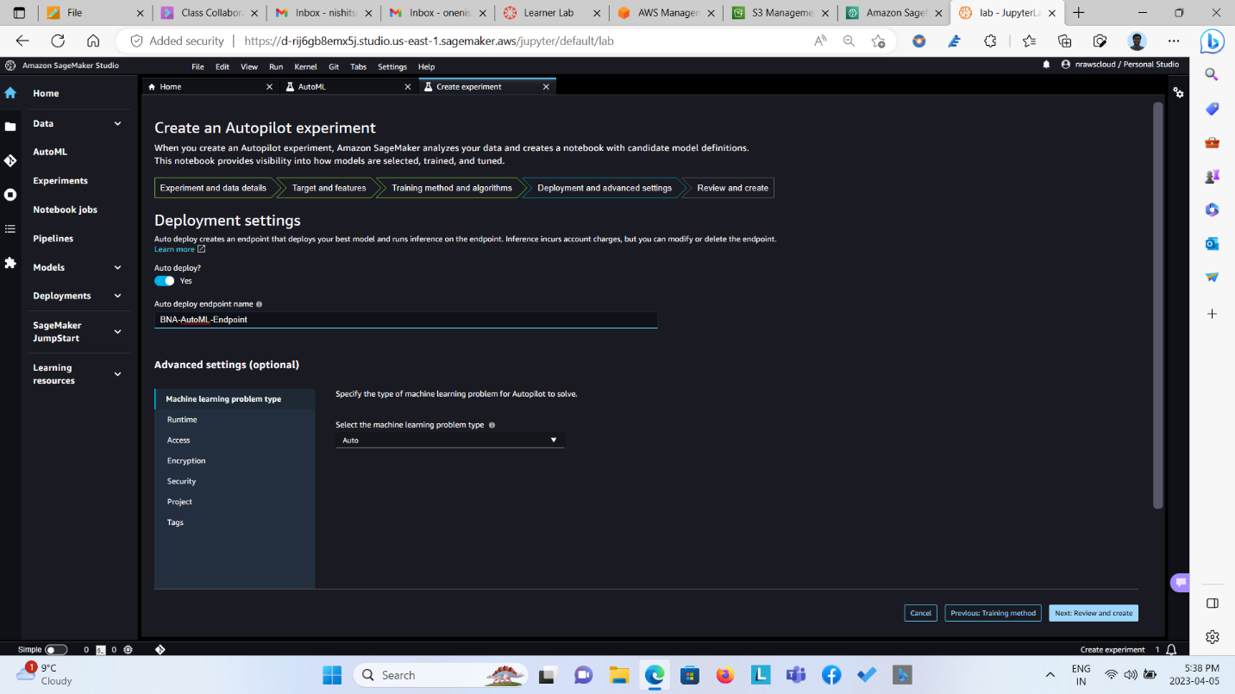  
  
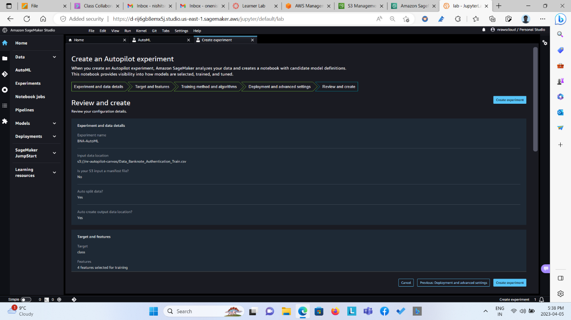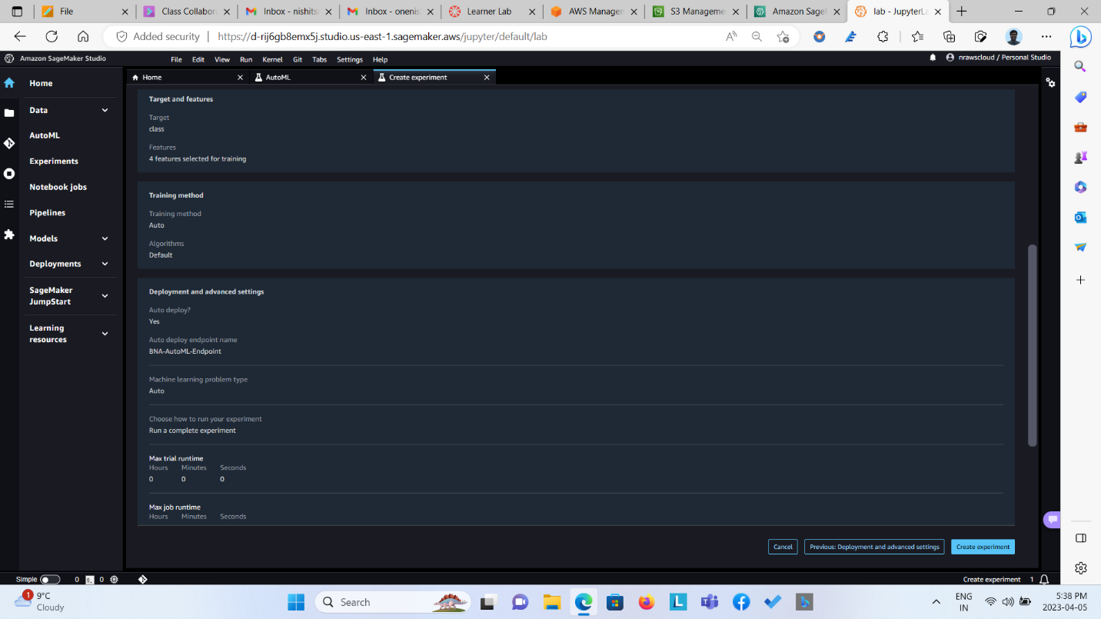  
  
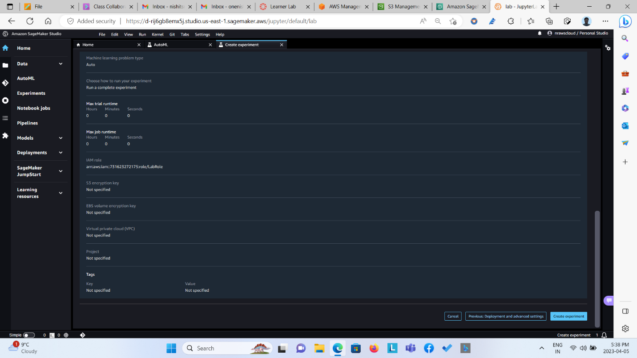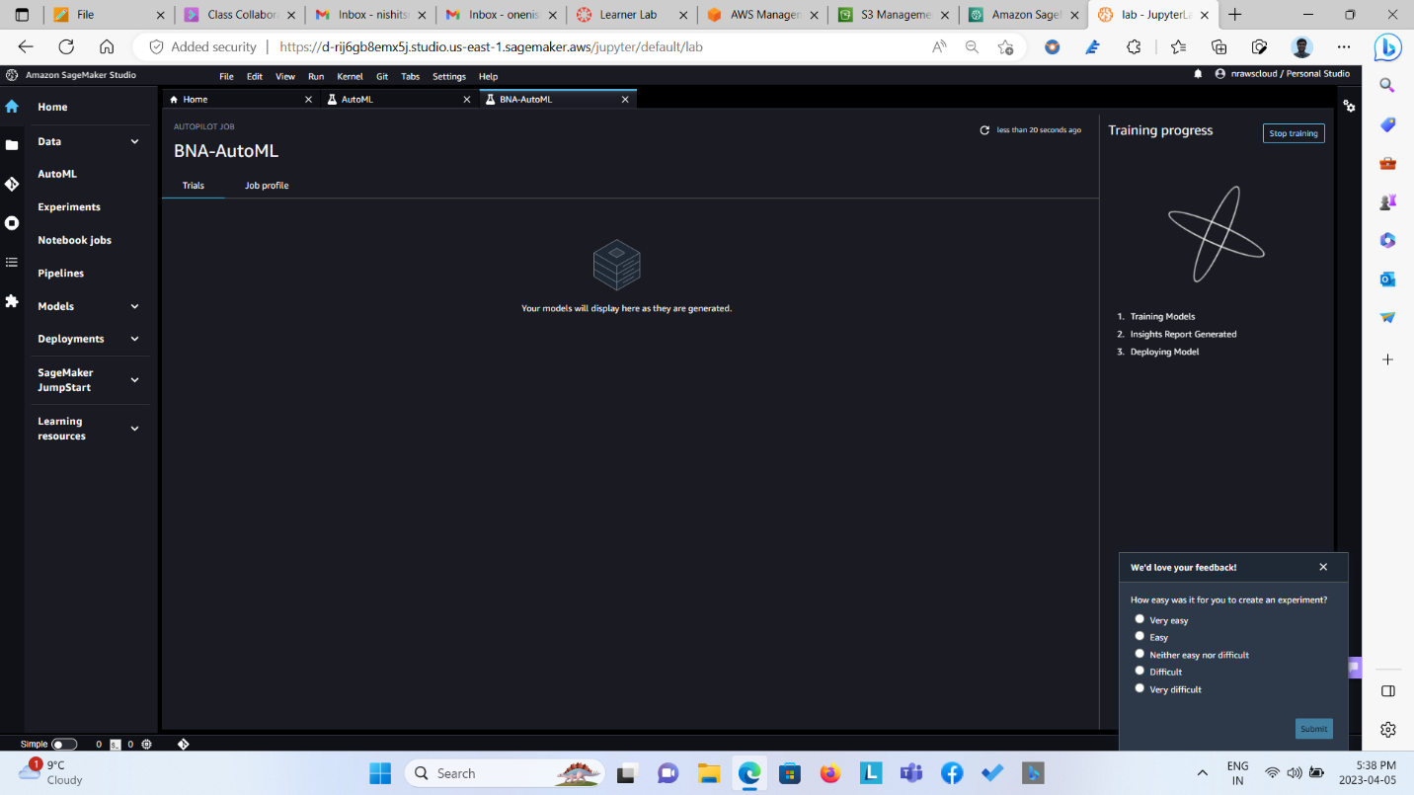  
  
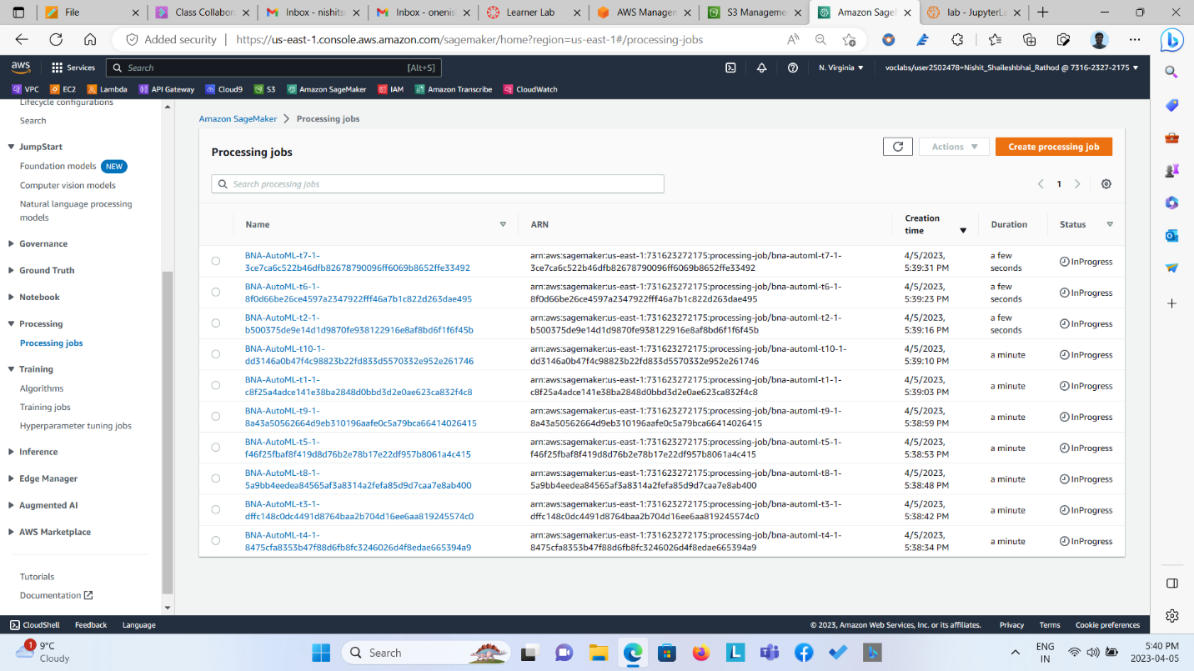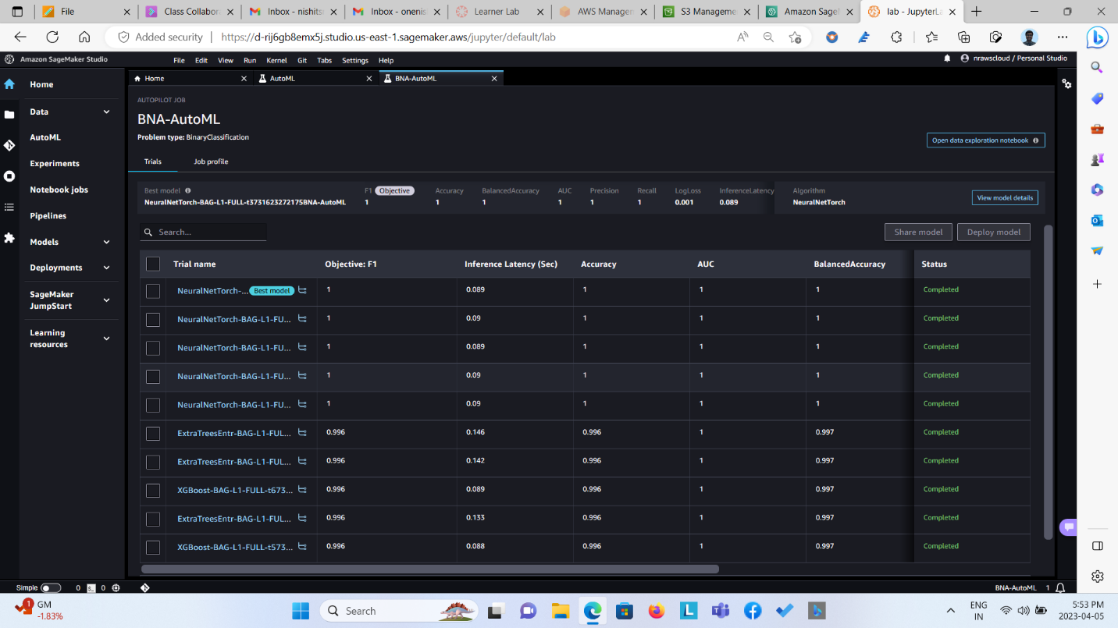  
  
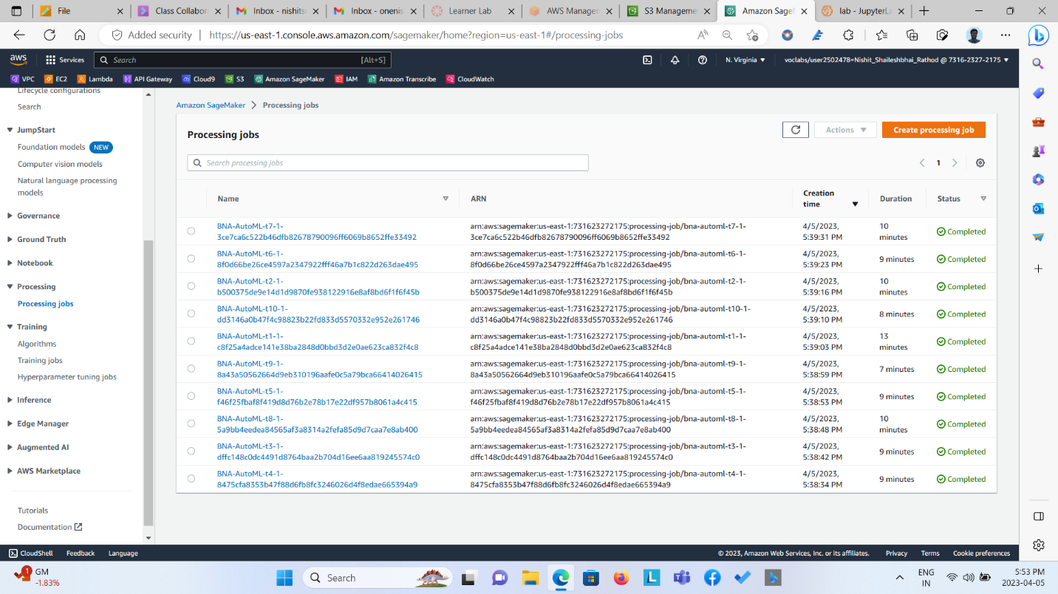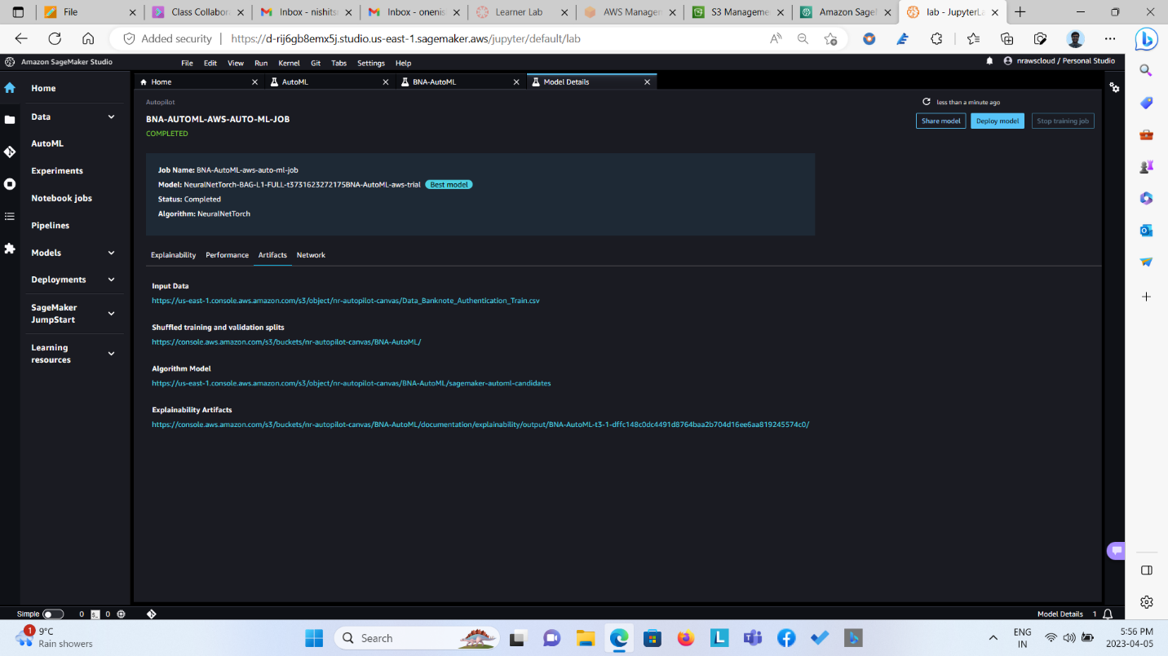  
  
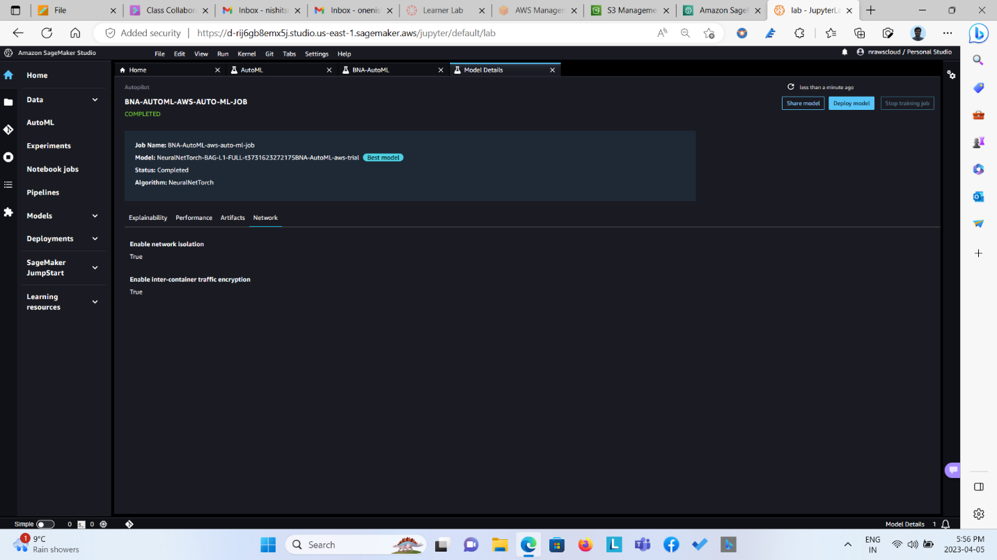

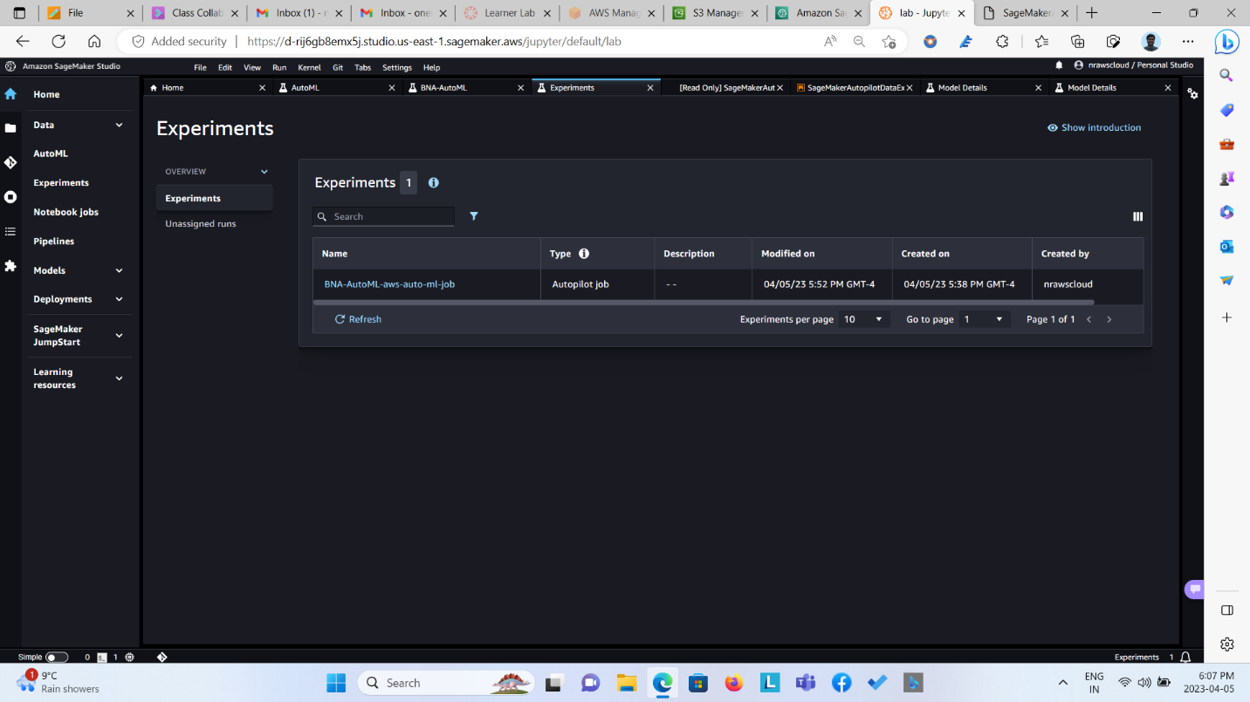  
  
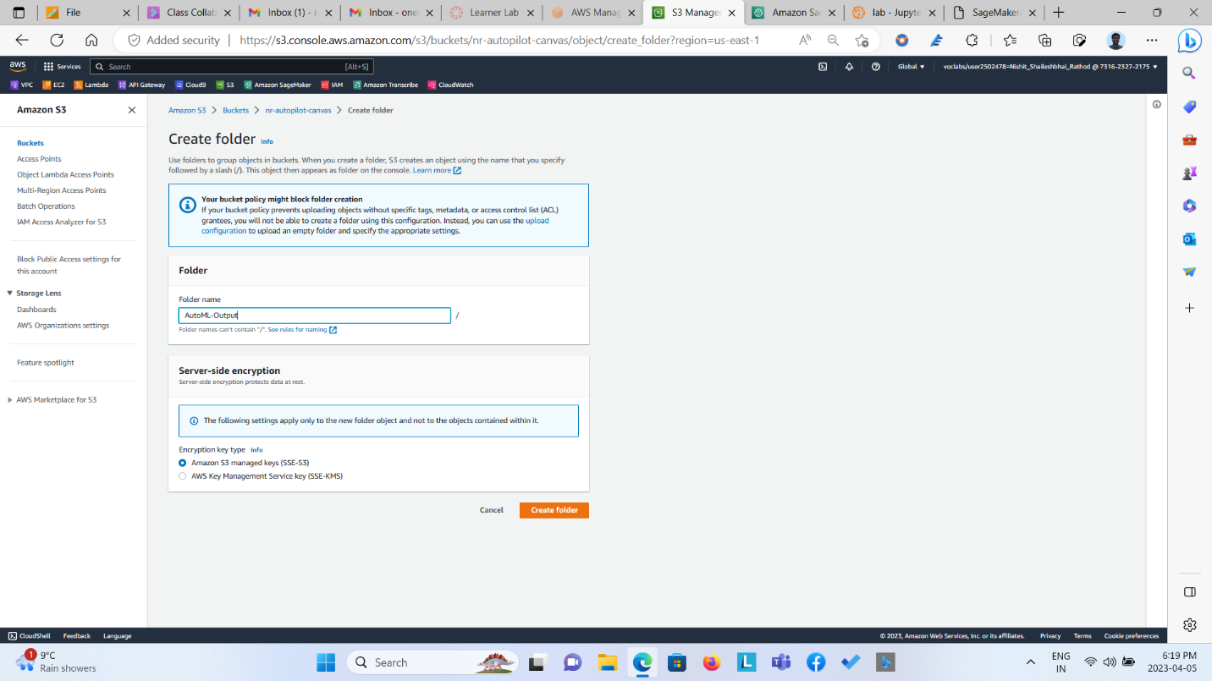

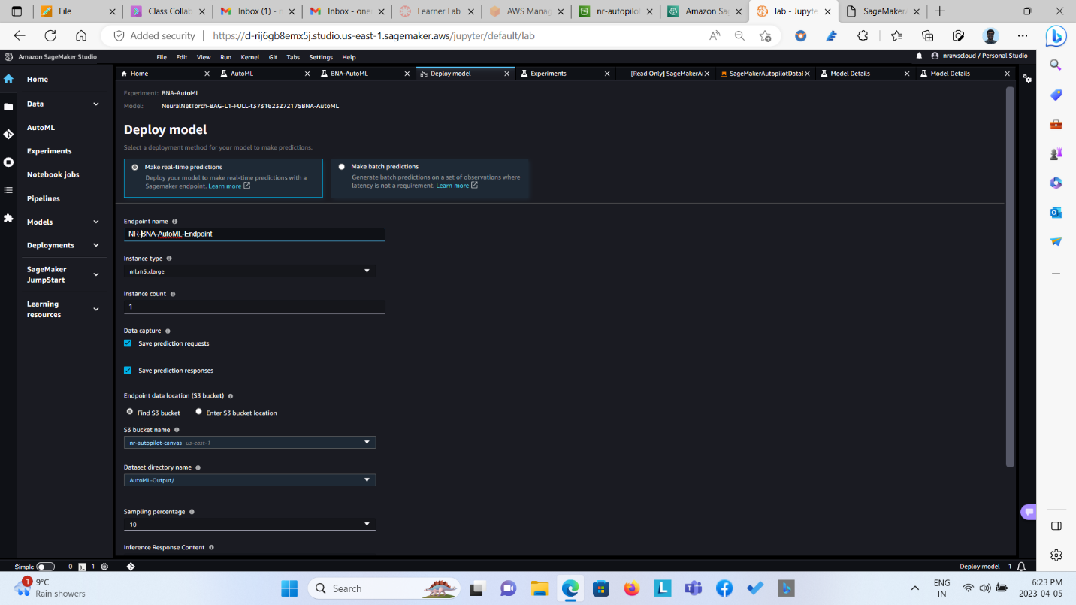  
  
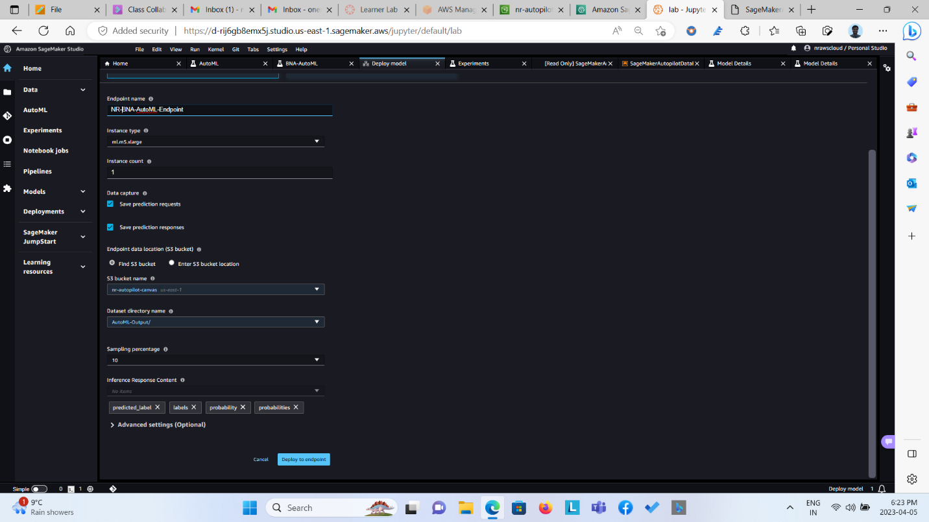

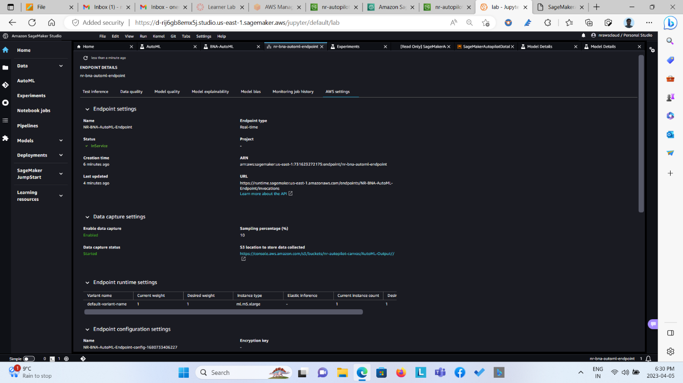  
  
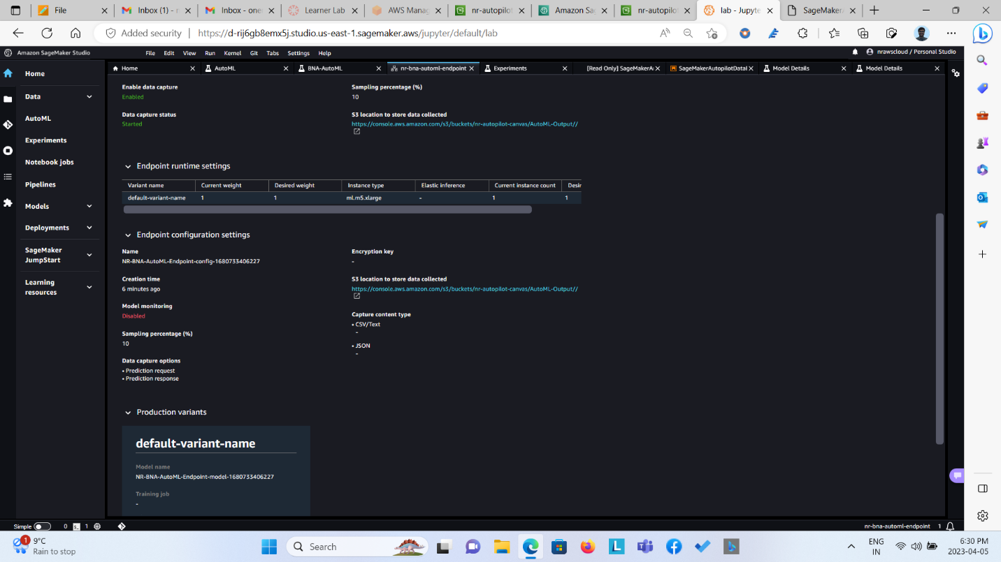

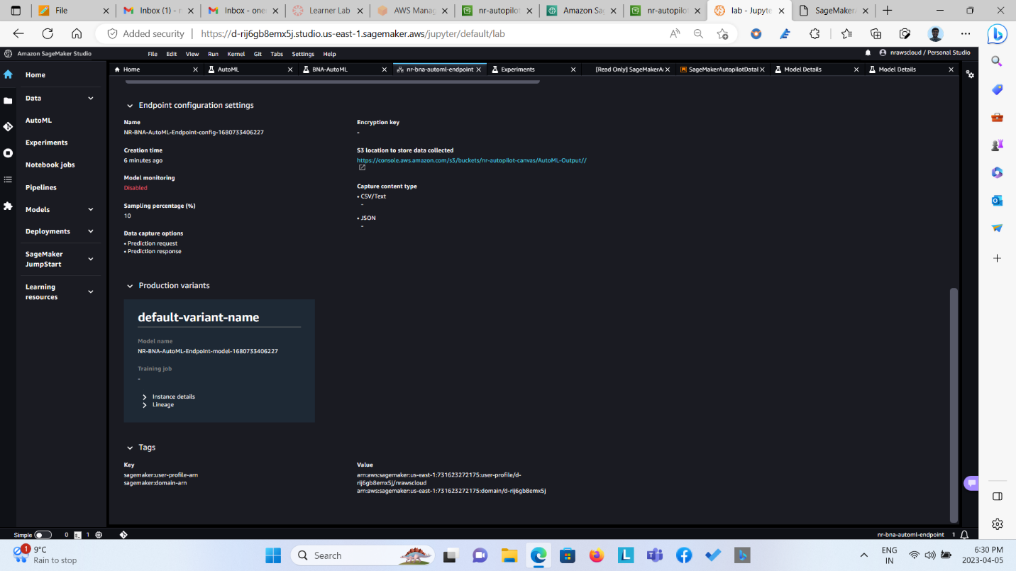  
  
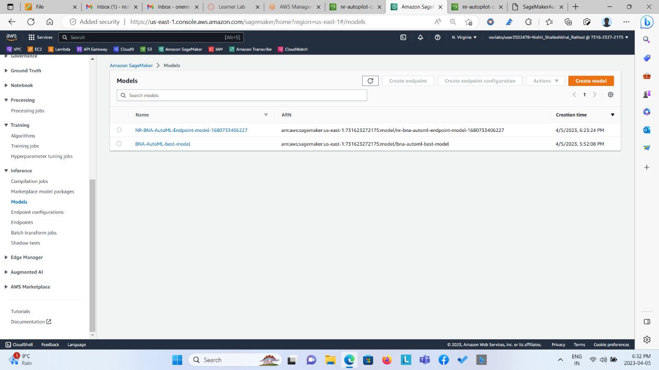  
  
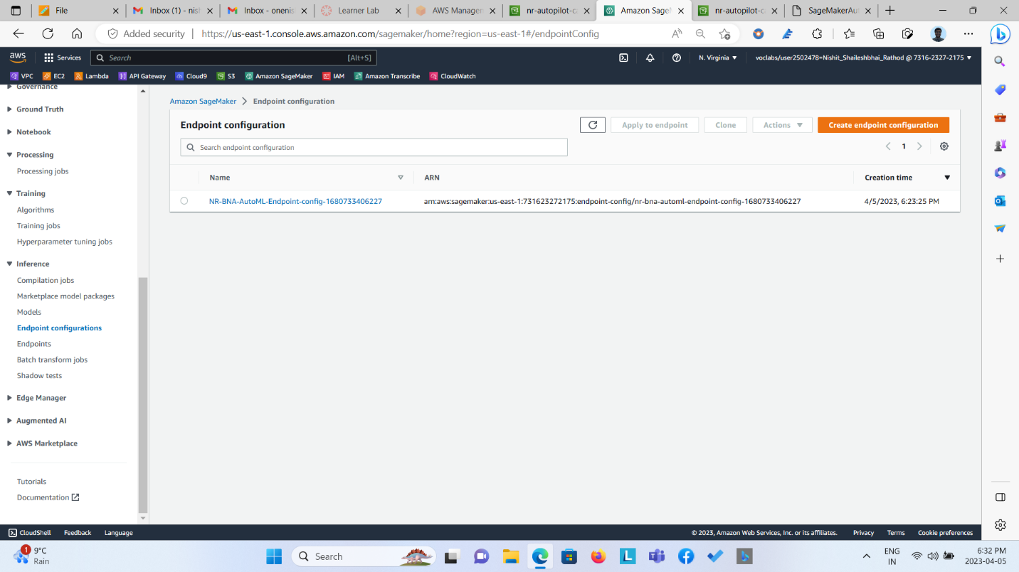  
  
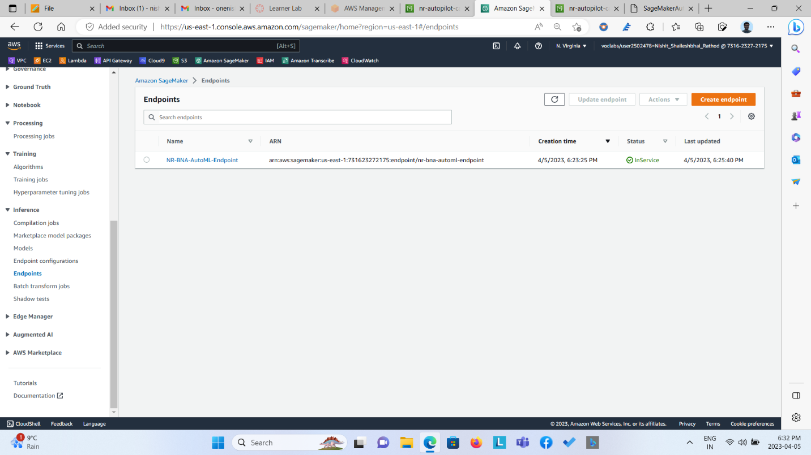  
  
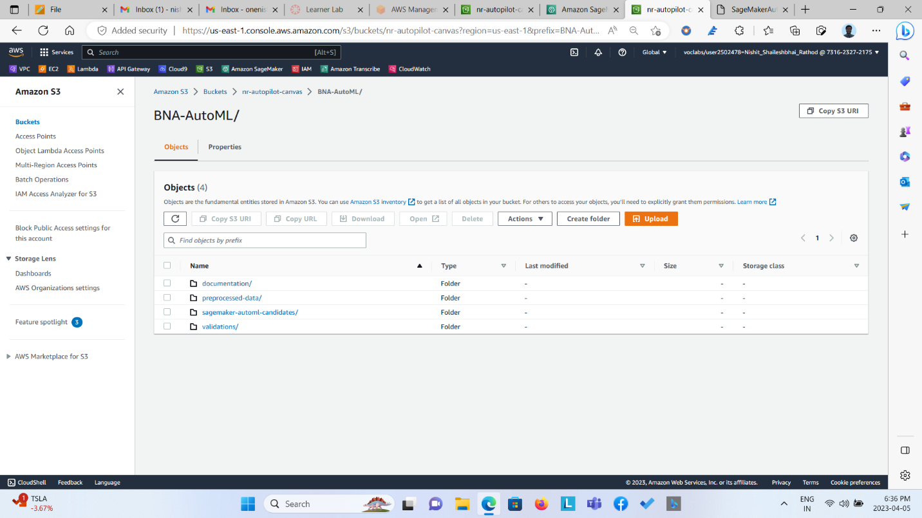

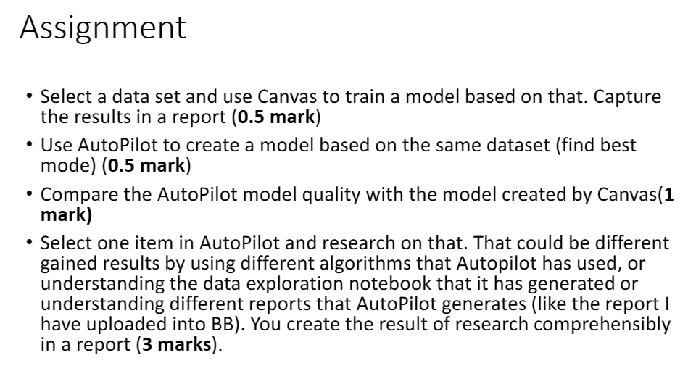

**Observations**

The Linear Learner Model trained on Canvas gave 100% accuracy in classifying banknote, whether the note is genuine or forged. The model evaluation metrics has identical results when compared to AutoML.

  
  
  
  


The models when implemented in Sagemaker Studio’s via. AutoMl also gave same accuracy of 100% in classifying Banknote. Among 10 models “Neural Net Torch BAG L1” gave the best classification results. The AutoML model evaluation metrics has identical results when compared to Canvas.



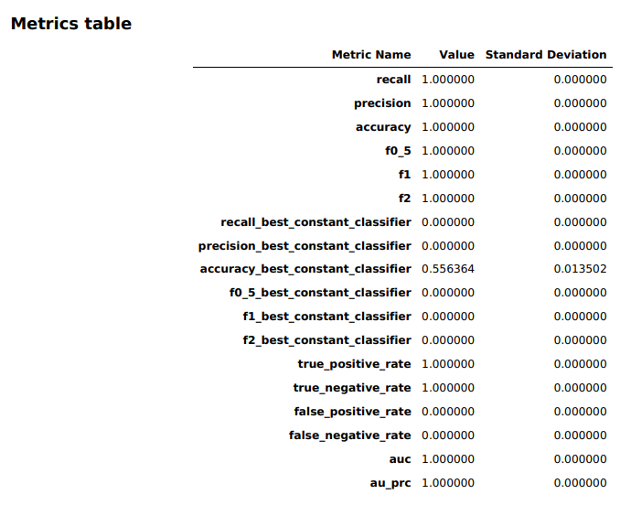

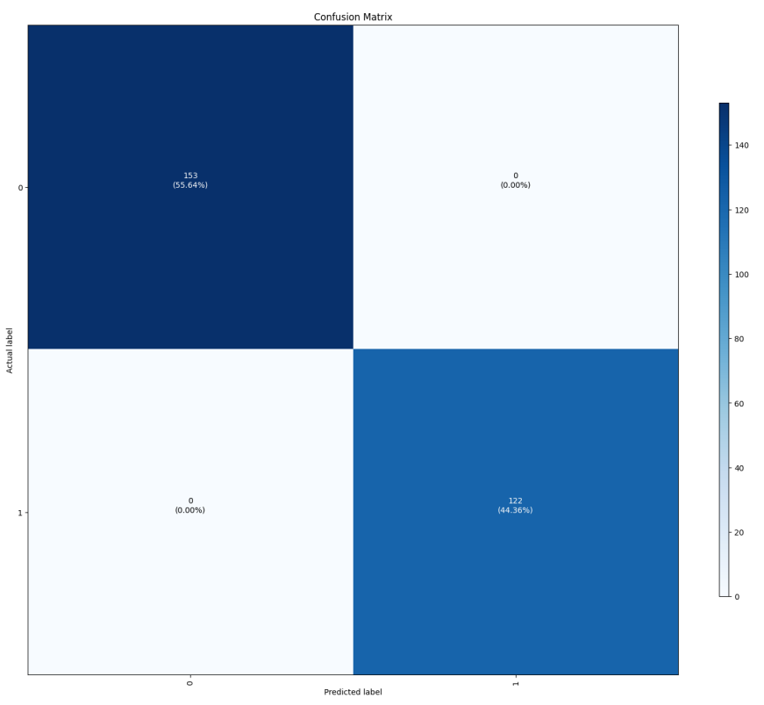

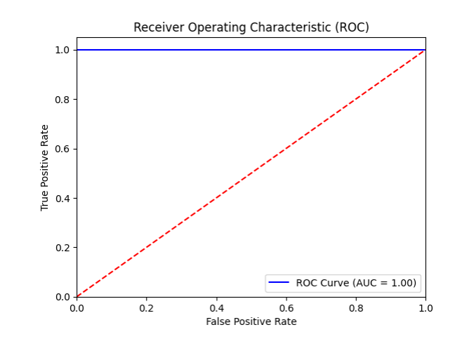

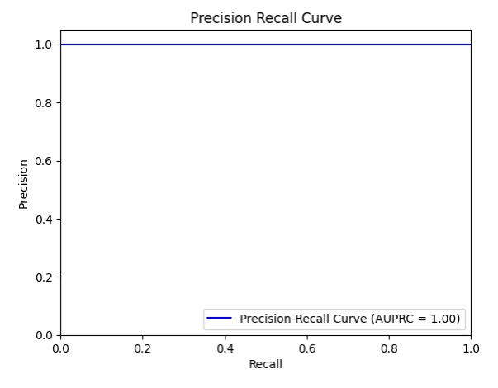

**Question**

Select one item in AutoPilot and research on that. That could be different gained results by using different algorithms that Autopilot has used, or understanding the data exploration notebook that it has generated or understanding different reports that AutoPilot generates (like the report I have uploaded into BB). You create the result of research comprehensibly in a report.

**Answer**

The thing on which, I had no knowledge was the Gain Curve and Lift curve which was derived and evaluated in the best model performance report i.e. on NEURAL NET TORCH BAG L1 FULL T3 model.

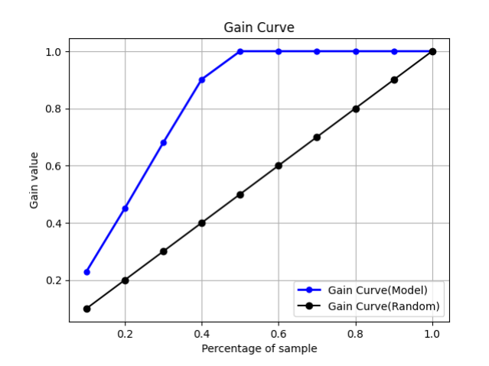

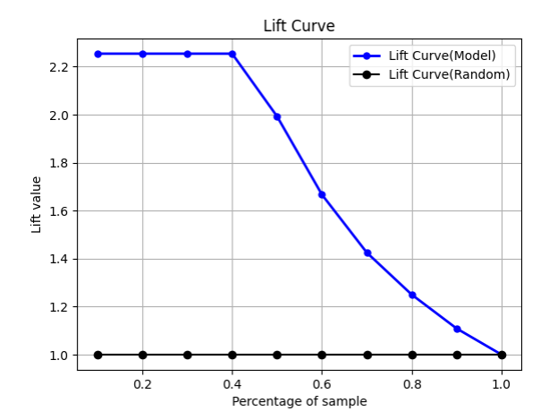

When researched more onto it I came to know that the Gain Curve and Lift Curve are two important evaluation metrics used in machine learning to measure the performance of binary classification models. Both of these metrics are based on the concept of ranking the predicted probabilities of a classifier and comparing them with the actual binary labels. Here, I will discuss in detail what Gain Curve and Lift Curve are, how they are calculated, and how they are used to evaluate machine learning models.

The gain curve and lift curve are two measures that are used for Measuring the benefits of using the model and are used in business contexts such as target marketing. It’s not just restricted to marketing analysis. It can also be used in other domains such as risk modelling, supply chain analytics, etc. In other words, Gain and Lift charts are two approaches used while solving classification problems with imbalanced data sets.

Example: In target marketing or marketing campaigns, the customer responses to campaigns are usually very low (in many cases the customers who respond to marketing campaigns are less than 1%). The organization will raise the cost for each customer contact and hence would like to minimize the cost of the marketing campaign and at the same time achieve desired response level from the customers.

The gain chart and lift chart is the measures in logistic regression that will help organizations to understand the benefits of using that model. So that better and more efficient output carry out.

**The gain and lift chart is obtained using the following steps:**

1. Predict the probability Y = 1 (positive) using the LR model and arrange the observation in the **decreasing order of predicted probability** [i.e., P(Y = 1)].
2. Divide the data sets into deciles. Calculate the number of positives (Y = 1) in each decile and the cumulative number of positives up to a decile.
3. **Gain** is the ratio between the cumulative number of positive observations up to a decile to the total number of positive observations in the data. The gain chart is a chart drawn between the gain on the vertical axis and the decile on the horizontal axis.

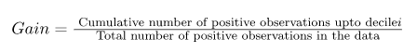

1. **Lift** is the ratio of the number of positive observations up to decile i using the model to the expected number of positives up to that decile i based on a random model. Lift chart is the chart between the lift on the vertical axis and the corresponding decile on the horizontal axis.



**Gain Chart Calculation:**

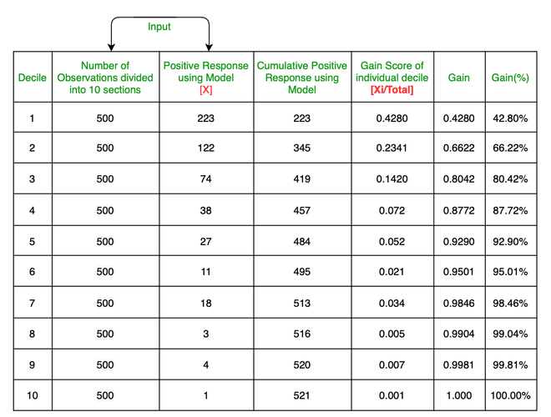

*Ratio between the cumulative number of positive response up to a decile to the total number of positive responses in the data.*

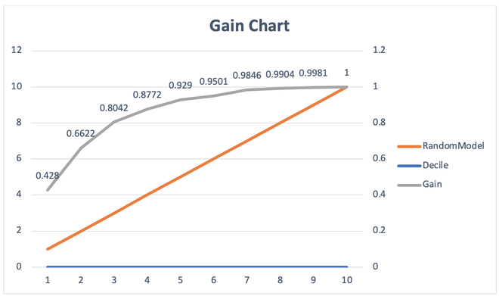

Lift Curve:

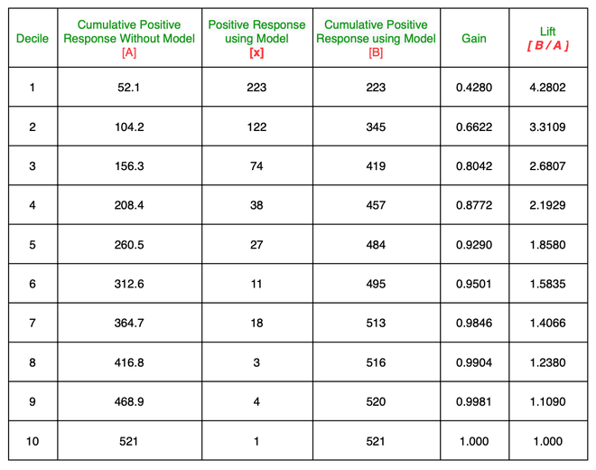

Ratio of the number of positive responses up to decile i using the model to the expected number of positives up to that decile i based on a random model

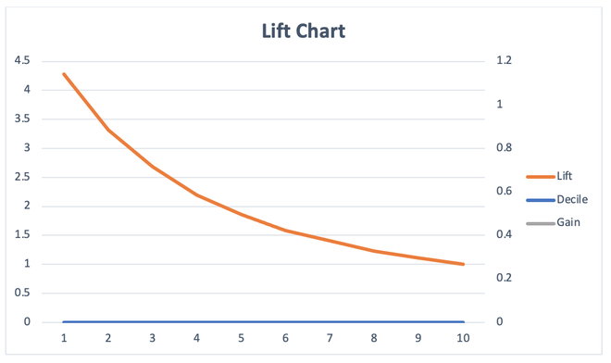

* Cumulative gains and lift charts are visual aids for measuring model performance.
* Both charts consist of Lift Curve (In Lift Chart) / Gain Chart (In Gain Chart) and Baseline (Blue Line for Lift, Orange Line for Gain).
* The Greater the area between the Lift / Gain and Baseline, the **Better** the model.